**NATIONAL TECHNICAL UNIVERSITY OF UKRAINE**

**«IGOR SIKORSKY**

**KYIV POLYTECHNIC INSTITUTE»**

**Faculty of Applied Mathematics**

**Department of Computer Systems Software**

«Admission to the defense»

Department Head

__________ Yevgeniya SULEMA

«___» _____________ 2023

**Diploma project**

**for a bachelor's degree**

**in the educational and professional program «Software Engineering of Multimedia and Information Retrieval Systems»**

**specialty 121 Software Engineering**

**on the topic: "Web-application for electronic commerce platform"**

Performer: 

4th year student, group КP-94

Mohamed Islam KHELILI __________

Supervisor:

Associate Professor of DCSS, Ph.D., Assoc. Prof.

Dmytro NOVAK __________

Consultant on normative control:

Associate Professor of DCSS, Ph.D., Assoc. Prof.

Mykola ONAI __________

Reviewer:

Associate Professor of NUHT , Ph.D., Assoc. Prof.

Andriy MOSHENSKY __________

I certify that in this diploma project there are no borrowings from the works of other authors without proper references.

Student _____________

(*signature*)

Kyiv – 2023

**National Technical University of Ukraine**

**"Igor Sikorsky Kyiv Polytechnic Institute"**

**Faculty of Applied Mathematics**

**Department of Computer Systems Software**

Level of higher education – first (bachelor's)

Specialty – 121 "Software Engineering"

Educational and professional program "Software Engineering of Multimedia and Information RetrievalSystems "

APPROVED

Department Head

________ Yevgeniya SULEMA

"___"_____________2023

**TASK**

**for the student's diploma project**

Mohamed Islam Khelili

1. The topic of the project "Web-application for electronic commerce platform", the supervisor Dmytro Novak, Ph.D., associate professor, approved by the order of the university dated "___"_________ 20___ №._____

2. The deadline for the student to submit the project "___" is June 2023.

3. Initial data for the project: see Technical task.

4. Contents of the explanatory note:

* + analysis of programming languages and website development technologies;
  + development of the web resource of the electronic commerce platform;
  + description of developed algorithms and routines;
  + analysis of the developed web resource.

5. List of mandatory graphic material:

* + user authorization (drawing);
  + data synchronization (drawings);
  + web resource architecture (poster);
  + structure of web application (poster);

6. Consultants of project sections

| Section | Surname, initials and position of the  consultant | Signature, date | |
| --- | --- | --- | --- |
| issued the task | accepted the task |
| Normative control | Onai M.V., associate professor |  |  |

7. The date of issue of the task is October 31, 2022.

Calendar plan

| No z/p | The name of the stages of the  diploma project | The term of execution of the  stages of the project | Note |
| --- | --- | --- | --- |
| 1. | Study of literature on the subject of the project | 13.11.2022 |  |
| 2. | Development and coordination of the technical task | 25.11.2022 |  |
| 3. | Development of the web resource structure | 15.12.2022 |  |
| 4. | Preparation of materials for the first section of the diploma project | 30.12.2022 |  |
| 5. | Development of page design and graphic elements | 02.02.2023 |  |
| 6. | Preparation of materials for the second section of the diploma project | 19.02.2023 |  |
| 7. | Software implementation of the web resource | 10.03.2023 |  |
| 8. | Web resource testing | 17.03.2023 |  |
| 9. | Preparation of materials for the third section of the diploma project | 30.03.2023 |  |
| 10. | Preparation of materials for the fourth section of the diploma project | 12.04.2023 |  |
| 11. | Preparation of the graphic part of the diploma project | 21.04.2023 |  |
| 12. | Completion of diploma project documentation | 26.05.2023 |  |

Student Mohamed Islam KHELILI

Supervisor Dmytro NOVAK

**ABSTRACT**

The diploma project devoted to the development of a web application for an electronic commerce platform. In today's digital age, electronic commerce has gained significant prominence as a convenient and efficient method for conducting business transactions. The web application aims to provide a user-friendly interface that enables seamless online shopping experiences for customers and facilitates effective management of the platform for business owners.

This project involves comprehensive research, analysis, and implementation of key features such as product catalog management, secure user authentication, shopping cart functionality, payment integration, and order processing. The web application designed with a responsive layout to ensure compatibility across various devices, allowing users to access the platform effortlessly from desktops, laptops, tablets, and smartphones.

The development process followed industry-standard methodologies, utilizing modern technologies and frameworks. For frontend HTML, CSS and JavaScript were used. Python and SQLite were used for backend. Additionally, the project employs robust security measures to protect sensitive user information and ensure secure online transactions.

The web-application for the electronic commerce platform holds immense potential to enhance the shopping experience for customers while offering business owners a powerful tool to expand their online presence and increase sales. The successful implementation of this project will contribute to the advancement of electronic commerce, bridging the gap between businesses and consumers in the digital marketplace.

**АНОТАЦІЯ**

Дипломний проект присвячений розробці веб-додатку для платформи електронної комерції. У сучасну цифрову епоху електронна комерція набула значної популярності як зручний і ефективний спосіб здійснення ділових операцій. Веб-додаток має на меті надати зручний інтерфейс, який забезпечує безперебійний досвід онлайн-покупок для клієнтів і полегшує ефективне керування платформою для власників бізнесу.

Цей проект передбачає комплексне дослідження, аналіз і впровадження ключових функцій, таких як керування каталогом продуктів, безпечна автентифікація користувачів, функціональність кошика для покупок, інтеграція платежів і обробка замовлень. Веб-додаток розроблено з адаптивним макетом для забезпечення сумісності з різними пристроями, дозволяючи користувачам легко отримувати доступ до платформи з настільних ПК, ноутбуків, планшетів і смартфонів.

Процес розробки відбувався за галузевими стандартними методологіями

* використанням сучасних технологій і фреймворків. Для фронтенду використовувався HTML, CSS і JavaScript. Python та SQLite було використано для бекенду. Крім того, у проекті застосовані надійні заходи безпеки для захисту конфіденційної інформації користувачів і забезпечення безпеки онлайн-транзакцій.

Веб-додаток для платформи електронної комерції має величезний потенціал для поліпшення покупок споживачами, пропонуючи власникам бізнесу потужний інструмент для розширення свого бізнесу в мережі інтернеті та збільшення продаж. Успішна реалізація цього проекту сприятиме розвитку електронної комерції, подоланню розриву між підприємствами та споживачами на цифровому ринку.

|  |
| --- |

DP.045440-01-90. Web-application for electronic commerce platform. Project information

| Marking | Name | Number | Note |
| --- | --- | --- | --- |
|  | Project documentation |  |  |
|  |  |  |  |
| DP.045440-02-91 | Web-application for | 4 |  |
|  | electronic commerce |  |  |
|  | platform. |  |  |
|  | Technical task |  |  |
|  |  |  |  |
| DP.045440-03-81 | Web-application for | 64 |  |
|  | electronic commerce |  |  |
|  | platform. |  |  |
|  | Explanatory note |  |  |
|  |  |  |  |
| DP.045440-04-51 | Web-application for | 4 |  |
|  | electronic commerce |  |  |
|  | platform. |  |  |
|  | Testing program and |  |  |
|  | Methodology |  |  |
|  |  |  |  |
| DP.045440-05-34 | Web-application for | 4 |  |
|  | electronic commerce |  |  |
|  | platform. |  |  |
|  | User manual |  |  |
|  |  |  |  |
| DP.045440-06-99 | Web-application for | 1 |  |
|  | electronic commerce |  |  |
|  | platform. |  |  |
|  | Database structure |  |  |

| Marking | Name | Number | Note |
| --- | --- | --- | --- |
|  |  |  |  |
| DP.045440-07-99 | Web-application for | 1 |  |
|  | electronic commerce |  |  |
|  | platform. |  |  |
|  | Entity-relationship |  |  |
|  | diagram |  |  |
|  |  |  |  |
| DP.045440-08-98 | Web-application for | 1 |  |
|  | electronic commerce |  |  |
|  | platform. |  |  |
|  | Compact disc |  |  |
|  |  |  |  |
|  |  |  |  |
|  |  |  |  |
|  |  |  |  |
|  |  |  |  |
|  |  |  |  |
|  |  |  |  |
|  |  |  |  |
|  |  |  |  |
|  |  |  |  |
|  |  |  |  |
|  |  |  |  |
|  |  |  |  |
|  |  |  |  |
|  |  |  |  |
|  |  |  |  |

**Faculty of Applied Mathematics**

**Department of Computer Systems Software**

"APPROVED"

Department Head

__________ Yevgeniya SULEMA

"___" ____________ 2023

**WEB-APPLICATION FOR ELECTRONIC COMMERCE PLATFORM**

**Technical task**

DP.045440-02-91

"AGREED"

Supervisor:

__________ Dmytro NOVAK

Normative control:

__________ Mykola ONAI

Performer:

__________ Mohamed Islam KHELILI

1

2023

**CONTENT**

1. Name and field of application ……………………………………………. 3
2. Basis for development …………………………….……………………… 3
3. Purpose of development ……………...…………………………………... 3
4. Requirements for the software product ………………...………………… 3
5. Requirements for project documentation ………………………..……….. 4
6. Design stages ………………...………………………………………… ... 5
7. The order of development testing ………..……………………………….. 5

2

**1. NAME AND FIELD OF APPLICATION**

**Development name**: Web-application for electronic commerce platform.

**Field of application**: information technologies.

**2. BASIS FOR DEVELOPMENT**

The basis for the development is a diploma design task approved by the Department of Computer Systems Software of the National Technical University of Ukraine "Igor Sikorsky Kyiv Polytechnic Institute".

**3. PURPOSE OF THE DEVELOPMENT**

The development is intended for use as a web-application for an electronic commerce platform. It serves as a digital marketplace where customers can browse, search, and purchase products online.

* 1. **SOFTWARE PRODUCT REQUIREMENTS**

1. Operating System: The web-application should be compatible with various operating systems such as Windows, Linux, and macOS.
2. Web Server: The web-application should be hosted on a reliable web server with sufficient storage, bandwidth, and processing power.
3. Database: A robust database management system should be used to store and manage product, customer, and order data.
4. Payment Gateway Integration: The web-application should be integrated with a secure payment gateway to enable online transactions.
5. Content Management System: A user-friendly content management system should be used to manage and update the website's content, products, and promotions.
6. Security: The web-application should implement robust security measures such as SSL certificates, firewalls, and regular backups to protect customer data and prevent cyber-attacks.
7. Analytics: The web-application should integrate with analytics tools to track user behavior, traffic, and sales data to inform marketing and sales strategies.
8. Performance Optimization: The web application should be optimized for fast loading speed, smooth user experience, and mobile responsiveness.
9. SEO: The web application should be optimized for search engines to improve visibility and attract organic traffic.
10. Integrations: The web application should integrate with third-party applications such as shipping, inventory, and email marketing tools to streamline operations and enhance customer experience

**5. REQUIREMENTS FOR PROJECT DOCUMENTATION**

The following documentation should be developed in the course of project documentation:

1. explanatory note;
2. testing program and methodology;
3. user manual;
4. drawings:

– "Database structure";

– "Entity-relationship diagram".

4

**6. DESIGNING STAGES**

Study of literature on the topic of the work …………………...16.11.2022

Development and coordination of the technical task ………….27.11.2022

Development of the structure of the web resource ……………15.12.2022

Development of page design and graphic elements ……….…..02.03.2023

Software implementation of the web resource ………………...15.03.2023

Testing of the web resource …………………………………....07.03.2023

Preparation of materials for the text part of the project ……..…28.04.2023

Preparation of materials for the graphic part of the project ........12.05.2023

Issuance of technical documentation of the project …….….......25.05.2023

**7. THE ORDER OF DEVELOPMENT TESTING**

Testing of the developed software product is performed in accordance with the "Testing program and methodology".

5

**Faculty of Applied Mathematics**

**Department of Computer Systems Software**

"APPROVED"

Department Head

__________ Yevgeniya SULEMA

"___" ____________ 2023

**WEB-APPLICATION FOR ELECTRONIC COMMERCE PLATFORM**

**Explanatory note**

DP.045440-03-81

"AGREED"

Supervisor:

__________ Dmytro NOVAK

Normative control:

__________ Mykola ONAI

Performer:

__________ Mohamed Islam KHELILI

1

2023

**CONTENT**

LIST OF TERMS AND ABBREVIATIONS ………………………….……….... 3

INTRODUCTION ………………………………………………….…….........…. 4

1. OVERVIEW OF EXISTING TECHNOLOGIES FOR WEB-APPLICATION DEVELOPMENT ……………………………………………………....…….. 5 1.1. Traditional marketing and e-commerce …..…….……..….…………….... 5

1.2. Web-application development tools …………………………….….….... 11

1.3. Conclusions of chapter 1 …………………………………….………….. 18

1. ANALYSIS OF PROGRAMMING LANGUAGES AND SOFTWARE DEVELOPMENT TECHNOLOGIES …….………….………….….….…..... 20

2.1. Analysis of client-side tools……………………………………..…..…... 20

2.2. Analysis of server-side tools …………………………………………..... 26

2.3. Conclusions of chapter 2 …………….…………………………..……… 30

1. DEVELOPMENT OF THE WEB-APPLICATION FOR ELECTRONIC COMMERCE PLATFORM …………………………………………..…....... 32 3.1. Analysis of the requirements ………………………….….…….……….. 32

3.2. Data synchronization …………………………………………..…........... 36

3.3. Conclusions of chapter 3………………………………………..….…..... 39

1. ANALYSIS OF THE DEVELOPED WEB-APPLICATION ……...……..… 41 4.1. Implementation of the web-application ……………….………..…….… 41

4.2. Testing of the web-application …………………………..……..….….... 51

4.3. Conclusions of chapter 4..……………………………………..……...… 59

CONCLUSIONS ……………………………………………..………………..... 61

LIST OF REFERENCES …………………..…………………………….….….. 62

APPENDICES ………………………………………………………………..…. 64

2

**LIST OF TERMS AND ABBREVIATIONS**

**HTML** (Hypertext Markup Language) – is the standard markup language used to create web pages and web applications.

**CSS** (Cascading Style Sheets) – is a style sheet language used to describe the presentation and layout of HTML (Hypertext Markup Language) documents.

**API** – stands for Application ProgrammingInterface **DB** – is a database.

**Bootstrap** – is a popular open-source front-end web development framework that provides a set of pre-designed HTML, CSS, and JavaScript components and tools.

**JS** – JavaScript.

**XAMPP** – Cross-Platform (X), Apache (A), MySQL (M), PHP (p), Perl (P).

**WWW** – World wide web.

**CMS** – Content Management System.

3

**INTRODUCTION**

E-commerce is rapidly gaining popularity as a widely accepted business model, with an increasing number of companies adopting online platforms for conducting business transactions. The focus of this project is to develop a versatile online store that allows customers to conveniently shop for various items, such as clothing, shoes, electronics, and more, from the comfort of their own homes. The availability of detailed product information and easy accessibility through retailer websites make online shopping an appealing and commonplace activity for consumers. Today's customers are attracted to the convenience, extensive options, competitive pricing, and user-friendly search functionality offered by online shopping platforms.

Additionally, business owners can benefit from reduced overhead costs associated with physical stores, enabling them to provide cost-effective purchasing options. The global reach of online purchasing expands the customer base, allowing businesses to cater to diverse backgrounds and enhancing overall customer value. An online store serves as a virtual platform where customers can browse through inventory, add desired items to a shopping cart, and proceed to checkout. During the checkout process, customers are prompted to provide necessary information such as billing and shipping addresses, delivery preferences, and payment details like credit card numbers or payment gateways.

4

**1.OVERVIEW OF EXISTING TECHNOLOGIES FOR WEB-APPLICATION DEVELOPMENT**

**1.1 Traditional marketing and e-commerce**

**1.1.1 *Traditional Marketing***

Traditional marketing, also known as offline marketing or conventional marketing, refers to the strategies and channels that have been utilized traditionally by firms to sell their products or services prior to the emergence of digital technology. Other names for traditional marketing are offline marketing and conventional marketing. It includes a wide variety of marketing strategies that have been used for many years to engage target groups and drive customer participation.

Offline channels, such as print media, television, radio, direct mail, billboards, and face-to-face contacts, have traditionally been the primary emphasis of traditional marketing activities. These channels were extremely important in terms of molding consumer views, building brand awareness, and propelling sales. Traditional marketing tactics are still relevant and continue to be utilized by firms across a wide variety of industries, despite the fact that digital marketing has seen a substantial rise in popularity over the course of the past few years [1].

The capacity of traditional marketing to reach a large and varied demographic of consumers is one of its most significant strengths. Advertisements shown on television and radio, for instance, have the capacity to concurrently communicate with millions of viewers and listeners. Likewise, print media such as newspapers and magazines can target particular geographic regions or specialist populations, enabling businesses to adjust their messaging in accordance with the specific audience or location being targeted.

Traditional marketing strategies also allow businesses to develop a discernible presence in the real world in which they operate. A visual effect is created by billboards, storefront displays, and other types of physical signage; this impact has the potential to attract the attention of pedestrians and generate brand recognition. In addition, direct mail marketing campaigns enable companies to

5

deliver promotional materials that are specifically targeted to people' mailboxes. This provides a more personalized touch and has the potential to generate higher response rates.

Traditional marketing has the capacity to provide customers with a multi-sensory adventure, which is another one of its many strengths. Advertisements broadcast on television and radio make use of both sight and sound to engage viewers' and listeners' emotional responses. Effective communication can be achieved through the use of visual aspects in print ads. These elements include colors, font, and imagery. Traditional marketing has the capacity to leave a long-lasting impression on customers since it appeals to numerous senses simultaneously [2].

In addition, traditional marketing has a lengthy history, which gives customers the impression that they are already familiar with it. Consumers are accustomed to the different channels and forms that it offers because it has been the dominant method of marketing for a considerable amount of time. This familiarity can create trust and credibility, as consumers frequently regard conventional marketing to be more established and trustworthy than newer digital marketing tactics. This is because customers are more likely to be exposed to traditional marketing.

Traditional marketing does not, however, come without its share of constraints. One of the most significant issues is how difficult it is to provide precise measurements of the efficacy of various initiatives. Traditional marketing frequently relies on estimates and indirect measures, which makes it difficult to determine the exact impact that marketing efforts are having. This is in contrast to digital marketing, which has powerful analytics and data tracking tools.

In addition, the manufacturing, distribution, and placement expenditures that are involved with traditional marketing channels tend to be significantly greater. For example, commercials shown on television and radio call for large expenses in creation as well as the purchasing of media and airtime. Printed advertisements come with costs associated with printing and distribution. These expenditures

6

might be out of the question for smaller companies with more constrained budgets [3].

In conclusion, traditional marketing has been an extremely important component of the marketing landscape, since it provides a variety of offline channels and promotional strategies to use when promoting products and services. Traditional marketing may not be as cutting-edge as its digital counterpart, but it still has several benefits that digital marketing cannot match, including a wider audience reach, more immersive sensory experiences, and a greater feeling of legitimacy. Businesses are able to develop comprehensive marketing campaigns that are able to effectively reach and engage their target audiences when they strike a balance between using traditional marketing methods and digital marketing strategies.

**1.1.2 *E-commerce***

E-commerce, which is an abbreviation for electronic commerce, has completely altered the way in which customers and businesses interact with one another in the context of trade and business. E-commerce has experienced exponential growth as a result of the rapid improvements in technology and the broad availability of the internet. E-commerce provides consumers and sellers with a global marketplace that is convenient, accessible, and easily accessible.

E-commerce can be broken down into its most basic components, which include the purchasing and selling of products and services through the use of electronic methods, most commonly carried out over the internet. It covers a broad spectrum of endeavors, including as online retail stores, business-to-business transactions, online auctions, digital payment systems, and plenty more. E-commerce has eliminated the need for physical travel by connecting people and companies all over the world and making it possible for transactions to take place without any complications across continents [4].

Because of the introduction of e-commerce, traditional business models have been radically disrupted, which has opened up opportunities that have never been seen before for new enterprises, established firms, and startups alike. Customers

7

are no longer restricted to shopping at local establishments nor are they bound by the standard operating hours of businesses. They are instead able to browse and make purchases of products or services at their own leisure, either from the convenience of their own homes or while they are on the move.

The ease of use that can be obtained through online shopping is one of the primary factors contributing to the expansion of this type of business. Customers may browse extensive product catalogues, compare prices, read reviews written by other customers, and then make educated purchasing selections with just a few clicks of the mouse. The capacity to do one's shopping over the internet removes the necessity of physically going to a store and offers access to a wider variety of goods, some of which may not even be sold in the immediate vicinity. In addition, the proliferation of mobile devices has made e-commerce even more approachable, allowing customers to shop online at any time and from any location.

The practice of conducting business online offers a wide variety of benefits to companies. It makes it possible for companies to broaden their consumer base beyond the confines of a specific geographic area and to communicate with people all over the world without having to set up traditional retail outlets. The overhead expenditures that are connected with physical retail premises and staffing can be significantly reduced by shopping at an online store, which is open round the clock. E-commerce also provides businesses with valuable insights and data on consumer behavior, which paves the way for more focused marketing, personalized recommendations, and continual optimization of the overall customer experience [5].

Despite its obvious advantages, though, conducting business online is not without its share of difficulties. Both consumers and organizations are exposed to considerable dangers as a result of growing concerns about data breaches and other forms of internet theft. Establishing confidence and ensuring that transactions are conducted in a secure environment are essential components of any successful online retail enterprise. In addition, the intense competition that exists in the online market place mandates that companies differentiate themselves from their rivals by

8

providing greater customer service, developing creative strategies, and effectively managing both logistics and supply chains.

Over the past few years, there has been a proliferation of new technologies, which has led to greater development in the field of online commerce. The landscape of e-commerce is undergoing a transformation due to the rise of technologies such as artificial intelligence (AI), machine learning, big data analytics, and augmented reality (AR), which are expanding personalization, improving customer interaction, and streamlining operations [6].

This analysis intends to explore the numerous components of an e-commerce website, including its structure, user experience, product offerings, sales performance, marketing techniques, customer support, and more. As we dive deeper into the realm of e-commerce, this report's goal is to investigate the various characteristics of an e-commerce website. Businesses may succeed in the digital world and provide extraordinary value to their customers if they have a solid understanding of the complexities of e-commerce and make effective use of its possibilities.

**1.1.3 *Revolution of Traditional Marketing***

The introduction of e-commerce has resulted in a sea change in the manner in which businesses approach marketing. As businesses adjust to the new digital environment, traditional marketing, which is dependent on physical channels, has experienced a substantial transition. Not only has the method of purchasing and selling goods and services been revolutionized by the advent of e-commerce, but the entire marketing ecosystem has also been impacted by this development.

Businesses now have the opportunity to connect with customers all over the world because to the rise of e-commerce, which has eliminated the geographical constraints that hampered earlier forms of marketing. Businesses that have an online presence are able to present their goods and services to potential clients around the clock, which enables customers to have access and convenience around the clock. This has enabled firms to compete on a worldwide scale by opening up

9

new markets for them to enter as well as expanding the consumer base they already had.

E-commerce has a number of crucial advantages over traditional marketing, one of the most significant of which is the capacity to personalize and target marketing messages to specific customer categories. Businesses are able to gain valuable insights about their consumers' tastes, behaviors, and purchase histories through the use of data analytics and tracking. This data may be used to design personalized marketing campaigns that resonate with specific customers, which increases the likelihood of a conversion as well as the likelihood that the customer will remain loyal to the brand [7].

E-commerce platforms also provide businesses with a plethora of marketing tools and tactics that were not available to them in traditional marketing. These tools and techniques were not available in traditional marketing. E-commerce would not exist without digital marketing tactics such as search engine optimization (SEO), pay-per-click (PPC) advertising, social media marketing, content marketing, and email marketing, to name just a few. These digital marketing strategies have become an essential component of the industry. These techniques give companies the ability to precisely target the demographic they want to reach, maximize the effectiveness of their marketing budgets, and monitor the progress of their campaigns in real time [8].

In addition, the process that customers go through to make purchases has been significantly altered by the rise of e-commerce. Consumers are now able to conduct product research and comparisons online, as well as read reviews and make educated purchasing selections without having to leave the comfort of their homes. This shift has pushed firms to develop content marketing tactics that provide relevant information, reviews, and product comparisons to aid customers in the process of making decisions about the products and services they wish to purchase. Establishing trust and credibility with clients enables businesses to enhance conversion rates and encourages customers to make additional purchases.

10

This may be accomplished by offering customers a streamlined and informative online experience.

The transition from offline to online marketing has also had an effect on the metrics that companies use to evaluate the success of their marketing initiatives. Businesses now have the capacity to track and analyze critical indicators including website traffic, conversion rates, customer engagement, and return on investment (ROI) thanks to the availability of tools for data analytics. This method is driven by data, which enables organizations to improve their marketing strategies, increase the effectiveness of their campaigns, and make decisions that are supported by data in order to increase their growth and profitability [9].

However, it is essential to keep in mind that despite the fact that the advent of e-commerce has ushered in a plethora of benefits, it also creates obstacles for companies. Because of the intense competition in the internet market, businesses constantly need to find new ways to improve and adapt in order to stay ahead of the pack. E-commerce businesses' levels of success are directly proportional to how well they manage aspects of their operations such as website design, user experience, online security, and customer support.

In conclusion, the shift away from traditional marketing towards e-commerce has profoundly changed the landscape of marketing. E-commerce has given businesses the ability to communicate with customers all over the world, customize their marketing messages, make use of data analytics, and implement cutting-edge digital marketing techniques. In this era of the digital revolution, the shift towards e-commerce has completely transformed the way in which companies sell their goods and services, presenting businesses with prospects for expansion and success that have never been seen before.

**1.2 Web-application development tools**

**1.2.1 *Web development***

Web development encompasses the process of building websites and web-based applications for the Internet or private networks, such as intranets. It covers a wide range of tasks, including web engineering, web design, web content creation,

11

client liaison, client-side scripting, web server and network security settings, and e-commerce development. Web development involves the non-design aspects of website creation, namely writing markup and coding. Recently, the term "web development" has also been associated with the development of content management systems (CMS). These CMSs can be custom-built or based on closed-source or proprietary systems. A CMS acts as an intermediary between users and databases through web browsers, providing a user-friendly interface for non-technical individuals to edit and manage their websites. The advantage of a CMS lies in its ability to empower users without requiring extensive technical knowledge [10].

Larger enterprises and organizations often employ teams of web developers, sometimes numbering in the hundreds, to create websites using standardized methodologies like Agile processes. In contrast, smaller businesses may only require the services of a single permanent or contract developer. Alternatively, they may allocate additional personnel to roles such as graphic designers or information systems technicians. Rather than being confined to a single department, web development often involves collaboration across various departments, fostering a multidisciplinary approach to achieve the desired outcomes.

A website is a collection of interconnected web pages, often containing multimedia content, that are hosted on one or more web servers and typically share a common domain name. It can be accessed through a unified resource locator (URL) over a private local area network (LAN) or a public Internet Protocol (IP) network, such as the Internet. Websites serve various purposes and can be utilized in different ways, including personal websites, corporate websites for businesses, government websites, or nonprofit organization websites. They can focus on specific topics or objectives, ranging from social networking and entertainment to news and education. The World Wide Web comprises all publicly accessible websites, while private websites, like those intended for a company's employees, are often part of an intranet [11].

12

Web pages are the building blocks of websites and are typically created using plain text with embedded formatting directives using HTML (HyperText Markup Language) or XHTML (eXtensible HyperText Markup Language). These pages can include content from other websites by using appropriate markup anchors. To view and transfer web pages, the Hypertext Transfer Protocol (HTTP) is employed, and for enhanced security and privacy, encryption through HTTPS (HTTP Secure) can be utilized. Web browsers, commonly used as the user's application, receive the HTML markup instructions and display the content of the web page on a display terminal.

Hyperlinks connecting web pages play a crucial role in facilitating the reader's comprehension of the website's organization and aiding in navigation. Typically, this navigation begins with the home page, which often features a comprehensive list of the website's content. Certain websites may require user registration or membership to access specific materials. Subscription websites encompass a wide range of categories, including business websites, news portals, academic journal platforms, gaming sites, file-sharing platforms, message boards, web-based email services, social networking platforms, real-time stock market data providers, and various other service-oriented websites [12].

A web page is a document designed to be viewed on the World Wide Web through a web browser on a computer or mobile device. It can also refer to a computer file, usually created using HTML or another markup language. Web browsers are responsible for rendering web pages, coordinating various online resources such as style sheets, scripts, and graphics to display the content as intended.

Web pages typically contain hypertext links that allow users to navigate to other web pages, often presented in a navigation bar or sidebar menu. A web browser can retrieve a web page from a remote web server over a network. The web server may restrict access to a private network, such as an intranet, or provide access to the entire World Wide Web. These requests are made using the HTTP protocol. Web applications powered by server-side code or client-side scripting can

13

generate dynamic web pages, while static web pages are delivered as stored files from the web server's file system. Dynamic web pages allow the browser to enhance the web page based on user input sent to the server [13].

**1.2.2 *Frontend and backend web development***

The front end of a web application or webpage encompasses the visual elements that users interact with, including fonts, colors, sidebars, and dropdown menus. Frontend developers are responsible for creating the look and feel of a website. This aspect of web development is often referred to as client-side development. HTML, CSS, and JavaScript are the primary languages used for frontend development. On the other hand, backend development focuses on the server, database, and the communication between the application and these components. Server-side languages such as PHP, Ruby, Python, and Java are used for backend development.

To better understand the differentiation between frontend and backend development, the following diagrams provide an illustration of their respective roles.

14

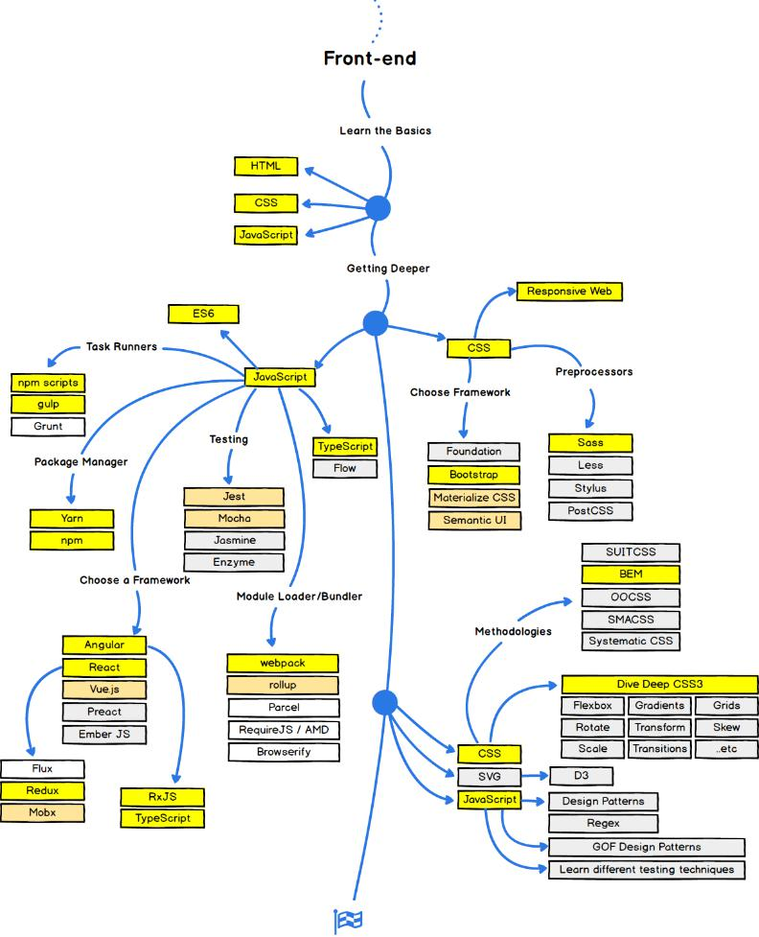

Fig. 1.1. Frontend development

15

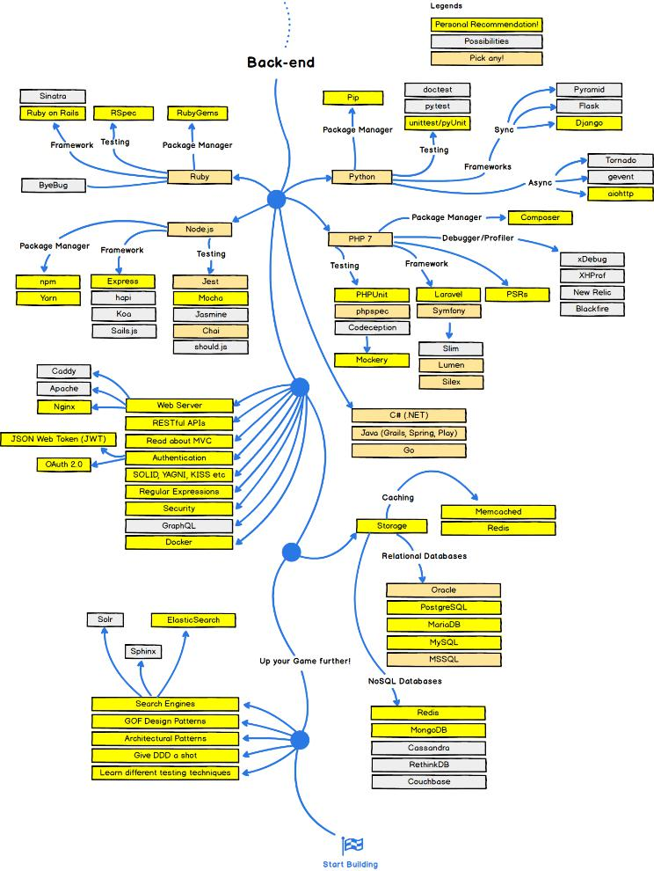

Fig. 1.2. Backend development

**1.2.3 *Programming Languages***

Here are some of the essential development tools commonly used in the electronic commerce:

Python: Python is a versatile and widely adopted programming language known for its simplicity and readability. It provides an extensive ecosystem of frameworks, libraries, and tools that facilitate web development. Python's clean syntax and rich set of libraries make it an excellent choice for backend development in e-commerce applications.

16

Django: Django is a high-level Python web framework that follows the Model-View-Controller (MVC) architectural pattern. It provides a powerful ORM (Object-Relational Mapping) system, allowing developers to interact with databases easily. Django also includes built-in security features, authentication mechanisms, and support for handling complex e-commerce functionalities.

Flask: Flask is another popular Python web framework that follows a minimalistic and lightweight approach. It provides the basic tools needed to build a web application and allows for more flexibility in customizing the development process. Flask is well-suited for small to medium-sized e-commerce platforms with specific requirements.

HTML (HyperText Markup Language): HTML is the standard markup language used for creating the structure and layout of web pages. It defines the elements and their placement on a webpage, including headings, paragraphs, images, forms, and more. HTML is crucial for creating the user interface and content presentation in e-commerce applications.

CSS (Cascading Style Sheets): CSS is used in conjunction with HTML to define the visual appearance and layout of web pages. It allows developers to specify colors, fonts, sizes, positioning, and other styling aspects. CSS plays a vital role in designing visually appealing and responsive user interfaces for electronic commerce platforms.

JavaScript: JavaScript is a powerful scripting language that runs on the client-side, enabling interactivity and dynamic content on web pages. It is commonly used for implementing features such as form validation, user interactions, real-time updates, and AJAX requests in e-commerce applications.

jQuery: jQuery is a fast and lightweight JavaScript library that simplifies client-side scripting tasks. It provides a wide range of pre-built functions and utilities, making it easier to manipulate HTML elements, handle events, perform animations, and interact with server-side components.

Bootstrap: Bootstrap is a popular CSS framework that offers a collection of pre-designed components, layouts, and styles. It provides a responsive grid system

17

and a set of CSS classes that make it easier to create mobile-friendly and visually appealing user interfaces for e-commerce applications.

SQL (Structured Query Language): SQL is the standard language for managing relational databases. In e-commerce applications, SQL is used for creating and managing product catalogs, handling customer data, processing orders, and performing various database operations efficiently.

RESTful APIs: REST (Representational State Transfer) is an architectural style for designing web services that enable communication between different components of an e-commerce platform. RESTful APIs allow for seamless integration of various functionalities, such as payment gateways, third-party services, and inventory management systems.

These are just some of the key tools and technologies used in web-application development for electronic commerce platforms. Depending on the specific requirements and complexity of the project, additional tools and frameworks may be utilized to enhance functionality, security, and performance. It is important for developers to stay updated with the latest advancements in these tools to build successful and competitive e-commerce applications.

**1.3 Conclusions of chapter 1**

Traditional marketing methods have been widely used in the past for promoting products and conducting business transactions. However, with the advent of technology and the rise of the internet, e-commerce has emerged as a powerful and effective way to reach a global audience. Web-application development tools play a crucial role in enabling businesses to create and manage online platforms for selling products and services.

Python, HTML, CSS, and JavaScript are essential tools for web-application development in the context of electronic commerce platforms. Python, with its versatility and extensive ecosystem, is well-suited for backend development and handling complex business logic. HTML and CSS are fundamental tools for designing the structure and appearance of web pages, while JavaScript allows for interactive and dynamic elements. Additionally, frameworks such as Django,

18

Flask, jQuery, and Bootstrap provide developers with pre-built components and utilities that streamline the development process.

The combination of these web-application development tools empowers businesses to create user-friendly, visually appealing, and functional electronic commerce platforms. These platforms provide opportunities for businesses to expand their reach, increase sales, and offer convenient shopping experiences to customers. As technology continues to evolve, staying up-to-date with the latest web-development tools and trends is crucial for businesses to stay competitive in the ever-growing e-commerce industry.

19

**2.****ANALYSIS OF PROGRAMMING LANGUAGES AND WEB-APPLICATION DEVELOPMENT TECHNOLOGIES**

**2.1 Analysis of client-side tools**

**2.1.1 *HTML***

The proliferation of the internet ushered in a new era in terms of how people gain access to and engage with various forms of information. This, in turn, led to the development of the World Wide Web and, subsequently, websites. HTML, which stands for "Hypertext Markup Language," is a foundational language that supports the structure and content of web pages. HTML is at the center of this digital revolution. HTML is the most important component of front-end development because it offers a standardized method for organizing information and presenting it in a way that is both aesthetically pleasing and interactive.

HTML makes use of a system known as tagging, in which individual elements are specified by tags that provide information regarding their purpose and function. These tags, which are denoted by the angle brackets ( >), encompass both the opening tags and the closing tags, so denoting the beginning and the end of an element. The content of a webpage is placed inside of these tags, which enables web developers to arrange and format text, graphics, links, forms, and other parts of a webpage.

HTML's capacity to generate a hierarchical structure, which can organise content in a way that is both logical and intelligible, is one of its most significant qualities. It is possible to nest elements within one another, so generating a parent-child relationship between the elements. The content may be arranged more easily with the help of this hierarchical structure, which also helps to ensure that the information is presented in a way that is consistent and easy to understand [14].

HTML elements can have attributes, which can be used to offer additional information about those elements. Developers are able to modify the functionality, appearance, and behavior of elements by specifying attributes within the opening tags of those components. Attributes are located within the opening tags of elements. A name and a value are the two components that make up an attribute.

20

The name identifies the particular attribute, while the value supplies the information or setting that corresponds to the name.

Over the course of its existence, HTML has developed to embrace a variety of new capabilities as well as standards. The most recent version of HTML, HTML5, has incorporated semantic elements, which are features that contain meaning and improve both the accessibility and search engine optimization of online pages. Developers are able to provide a clearer understanding of the structure and purpose of content by making use of semantic elements like header>, nav>, section>, article>, and footer>. This is to the benefit of users as well as search engines.

Even though HTML is the building block of a webpage, it frequently works in conjunction with other markup languages like CSS (Cascading Style Sheets) and JavaScript to improve the aesthetics and functionality of webpages. The use of cascading style sheets, or CSS, to apply styles to HTML elements, such as colors, fonts, and layouts, enables customization while maintaining uniformity across different web pages. On the other side, JavaScript provides developers the ability to include interactivity and dynamic behavior into web pages, thereby producing compelling user experiences [15].

HTML is an essential language in the process of developing websites because it lays the groundwork and framework for creating websites that are both interactive and visually engaging. Developers are able to successfully organize content and present it in a manner that is friendly to users if they have a solid understanding of the fundamental ideas, components, and properties of HTML. This section's goal is to present a thorough introduction to HTML, focusing on the language's significance in front-end development and its indispensable part in sculpting the experience of using the modern web.

21

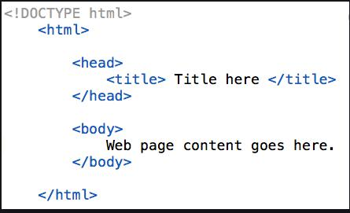

Fig. 2.1. Structure of HTML

**2.1.2 *CSS***

The use of cascading style sheets, also known as CSS, is an essential part of contemporary web development. These sheets play a vital part in improving both the aesthetic look and the layout of websites. CSS stands for "cascading style sheets," and it is a language that is used in conjunction with HTML to manage the appearance of web content. This includes the colors, fonts, spacing, and placement of the information. A website's developers are able to produce designs that are aesthetically engaging and consistent when they employ CSS. These designs can improve the user experience and reflect the website's brand identity.

The purpose of this part is to provide a comprehensive examination of CSS and the role that it plays in front-end development. We are going to go into the fundamental ideas, capabilities, and uses of CSS in order to provide a full understanding of its purpose in determining the aesthetics and functionality of web sites.

The cascading style sheet (CSS) is based on a rule-based system, which means that rules may be developed to target particular HTML elements and apply various styling features. It is possible to identify the items that need to be styled by making use of selectors such as class, ID, and element selectors. The look of these components can be modified, along with their layout, through the use of a variety of stylistic characteristics, including as color, font size, margin, padding, and background. Developers can do this.

The capability of CSS to divide a web page's display layer from its content layer is one of the most significant benefits offered by this markup language. This

22

separation enables a clean and organized code structure, which in turn makes it much simpler to manage and update styles across a number of different pages. The developers of a website are able to create consistency throughout the entire site and make global modifications in an effective manner if the stylistic instructions are centralized in a separate CSS file. Cascading is another feature that is introduced by CSS. This allows many styles to be applied to a single element, and any conflicts are resolved according to the element's specificity and the sequence in which the styles were declared. This cascading behavior gives developers the ability to construct designs that are flexible and responsive, allowing them to adjust to a variety of screen sizes and devices. The usage of media queries, which is a component of CSS, enables the smooth and enhanced optimization of the surfing experience by enabling the customization of styles based on the features of the user's device [16].

CSS includes a variety of advanced layout capabilities that extend beyond fundamental placement. Both CSS Grid and Flexbox are highly effective layout frameworks that provide web developers with the ability to design intricate and interactive page architectures. These layout tools provide exact control over the placement and alignment of elements, which enables designers to create designs that are complex and responsive. Preprocessors for CSS, like Sass and Less, provide additional functionalities and features that are similar to programming in order to improve the development process. They do this by introducing notions such as variables, mixins, and functions, which enables developers to design CSS code that is reusable and modular, hence increasing productivity and making the code easier to maintain.

Cascading Style Sheets (CSS) is a language that is crucial to the frontend development process since it gives developers the ability to control the visual appearance and layout of web content. Developers are able to construct websites that are aesthetically pleasing and friendly to users if they have a solid understanding of the fundamental concepts, selectors, and layout approaches that CSS offers. This section will attempt to provide a comprehensive examination of

23

CSS, focusing on its relevance to the process of developing websites as well as its power to alter both the appearance and the functionality of online pages.

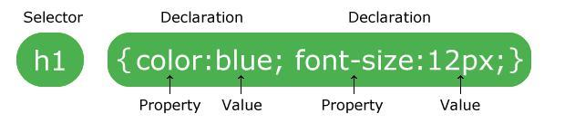

Fig. 2.2. CSS syntax

**2.1.3 *JavaScript***

JavaScript is a programming language that is used to create dynamic web pages and add interactivity to web applications. It is a popular and powerful language that can be executed within a web page in a browser. Many big companies like Netflix, Walmart, and PayPal have built entire applications using JavaScript. With JavaScript, you can create real-time networking applications like chats and video streaming services, command-line tools, and games. Additionally, JavaScript allows you to create complex web applications that can perform tasks like sending HTTP requests and manipulating HTML and CSS code.

Many big companies like Netflix, Walmart, and PayPal have built entire applications using JavaScript. This demonstrates the power and flexibility of the language. JavaScript's popularity can be attributed to its ability to run within a web page in a browser, making it accessible to anyone with an internet connection. Furthermore, JavaScript is easy to learn, making it a great language for beginners to start with.

JavaScript was first introduced in 1995 as LiveScript by Netscape. The name was later changed to JavaScript due to the popularity of Java. Despite the name change, JavaScript has nothing in common with Java and is an independent language. Initially, JavaScript was used for spamming, annoying overlays, and pop-ups. However, it has since evolved to become a more robust language with a wide range of applications.

JavaScript is an interpreted language, meaning it is compiled at runtime rather than during development. It is designed to run in a browser, and every browser has a JavaScript engine that can execute JavaScript code. Google's

24

JavaScript engine, known as V8, was extracted to run JavaScript anywhere, and many non-browser environments, such as Node.js and Adobe Acrobat, also use JavaScript.

One of the main advantages of JavaScript is its ability to manipulate HTML code, CSS, and send background HTTP requests. This means that you can use JavaScript to create web pages that can respond to user interactions without reloading the entire page. To use JavaScript in HTML, you need to put your code between the <script> and </script> tags. This allows the browser to identify the JavaScript code and execute it accordingly.

In summary, JavaScript is a powerful and versatile language that has revolutionized web development. It is used to create dynamic web pages, add interactivity to web applications, and perform complex tasks like sending HTTP requests and manipulating HTML and CSS code. Despite its humble beginnings, JavaScript has become one of the most widely used programming languages in the world, and its importance is only set to increase in the future.

**2.1.4 *Bootstrap***

Bootstrap is a front-end development framework that has become very popular among developers and designers. It's flexible, easy to use, and lets you build fully responsive websites quickly. With Bootstrap, you don't need to spend hours coding your own grid because it comes with a responsive grid system. You can easily add a range of components like navigation bars, dropdowns, progress bars, and thumbnails to your web pages. Bootstrap's website explains each piece of code in detail, making it easy for developers to understand how it works and how to use it effectively.

Bootstrap can be used with any IDE or editor, and with any server-side technology and language from ASP.NET to PHP to Ruby on Rails. Its popularity is due to the fact that it has a large community of designers and developers behind it who contribute to its development and make it even more effective. Bootstrap is hosted on GitHub, making it easy for developers to modify and contribute to its codebase.

25

One of the main benefits of Bootstrap is its ability to resize images automatically based on the current screen size. Additionally, there are many custom jQuery plugins available in Bootstrap. However, one of the main criticisms of frameworks like Bootstrap is their size and the amount of code they use, which can slow down the application upon first load. To solve this issue, developers have started to create templates based on Bootstrap to speed up the web development

**2.2 Analysis of server-side tools**

**2.2.1 *Python***

Python is a very popular programming language that can be used for backend web development since it is a tool that is both reliable and flexible. Python is quickly becoming the programming language of choice for developers looking to create dynamic and scalable online applications due to its ease of use, high level of readability, and wide availability of libraries and frameworks.

Python, at its heart, offers programmers a syntax that is both powerful and expressive, which enables them to write code that is both clean and efficient. Because of its straightforward nature and high level of readability, it is suitable for use by novice as well as seasoned programmers, which helps to promote teamwork and ease of maintenance within development groups. The emphasis that Python places on readability of code is in line with the concepts that underpin the Pythonic philosophy, which places an emphasis on the clarity and simplicity of code.

The wide standard library that comes with Python offers a diverse collection of functionalities that are easily accessible for the creation of backends. This library consists of modules that may handle a variety of activities, including data serialization, network connectivity, and file management, among others. When developers make use of these pre-built modules, they greatly reduce the amount of times they have to "reinvent the wheel." This frees them up to concentrate on higher-level application logic.

Python has a wide ecosystem of third-party libraries and frameworks that, in addition to the standard library, further enhance its capabilities for backend development. These features include the ability to create web applications. Popular

26

frameworks such as Django, Flask, and Pyramid offer potent abstractions and tools for the construction of online applications. These frameworks provide functionality such as URL routing, database integration, session management, and user authentication. The Model-View-Controller (MVC) architectural paradigm is used by these frameworks, which helps to promote separation of concerns and code organization [17].

Python's adaptability is not limited to web development; the programming language may also be used for a variety of backend operations, such as data processing, server scripting, and automation. Its strong support for database connectivity enables smooth integration with various database systems, which enables efficient data storage and retrieval, and it does this through libraries such as SQLAlchemy, which are examples of the kind of assistance it provides.

The ability of Python to interface with various other technologies and service is one of the programming language's strongest points. Because it is capable of communicating with external APIs, doing web scraping, and interacting with a variety of protocols, it is an excellent choice for developing scalable and robust online applications that integrate with a variety of external services and systems.

The cross-platform interoperability of Python assures that applications written with Python can run on a variety of operating systems, which makes deployment and distribution much simpler. When designing backend systems that need to function in a variety of situations, the independence of the platform from which they are built is a big advantage.

The support that Python receives from its community is another significant feature of the programming language. The huge and active community that uses Python makes contributions to the development of libraries, frameworks, and tools. This ensures that improvements and support are continuously being made. This strategy, which is driven by the community, encourages collaboration within the Python ecosystem, as well as the exchange of information and ongoing improvement [18].

27

Python is an effective and adaptable programming language that can be used for the backend development of websites. For the purpose of constructing online applications that are scalable, efficient, and easy to maintain, it is an excellent choice because of its ease of use, readability, wide library support, and active community. Developers are able to design sophisticated backend systems that power dynamic and data-driven websites by leveraging Python's extensive ecosystem of tools, frameworks, and integrations when using this programming language.

**2.2.2 *Django***

Django is a high-level Python web framework that offers an extensive collection of tools and functions for the purpose of facilitating the building of websites in a quick and effective manner. Django is an open-source web application framework that was developed to adhere to the Model-View-Controller (MVC) architectural pattern. As a result of its clean and organized code structure, it has become a popular option for the construction of online applications that are scalable and easy to maintain.

The fact that Django places such a strong focus on productivity and the reusability of code is one of its most notable advantages. The "Don't Repeat Yourself" (DRY) principle that underpins Django encourages developers to build components that can be reused and to reduce the amount of redundant code they produce. Django automates common web development activities by providing a powerful set of built-in features and standards. This enables developers to focus on building application-specific logic rather than doing mundane web development tasks.

The robust Object-Relational Mapping (ORM) layer that is included into Django's basic features is what makes it possible for developers to interface with database tables by means of Python objects. The Object-Relational Mapper (ORM) offers a practical method for defining database models and carrying out database operations without the need to write raw SQL queries. It is compatible with a wide

28

range of database backends, including well-known systems such as MySQL, PostgreSQL, and SQLite [19].

Django's URL routing system is another one of its prominent features. This system maps URLs to the views that correspond to those URLs. Developers are able to define patterns and associate those patterns with view functions or classes through the use of the URL configuration. This decoupling of URLs and views offers flexibility as well as maintainability, making it possible to easily modify and extend application routes.

Django comes with a powerful templating engine that gives developers the ability to create HTML templates that are both dynamic and reusable. The templating engine enables template inheritance, which makes it possible to create basic templates that share elements with other templates and reduces the amount of code that must be duplicated. In addition to this, it has control structures, filters, and template tags that can be used within templates to change and display data.

The built-in authentication and authorization system that comes standard with Django is one of the key advantages offered by this framework. It simplifies the process of implementing safe user authentication for online applications by providing user management, registration, and login features out of the box. Developers are able to restrict user actions based on preset roles and permissions thanks to Django's permission system, which also provides fine-grained access control. Django also enables fine-grained access control.

The administration interface provided by Django is yet another great feature that makes content management more straightforward. It allows administrators to monitor and interact with the application's data without requiring them to write additional code because it automatically provides a configurable admin interface based on the given models.

Django provides support for internationalization and localization, which makes it possible for developers to construct applications that are geared towards a global audience. It offers capabilities for translating application text and managing the layout of dates and numbers based on a variety of locales.

29

Because of Django's extensibility, developers are able to incorporate third-party libraries and create reusable Django applications, which are referred to as "Django apps." This is a significant benefit of Django. The Django Package Index, also known as PyPI, is home to a massive number of Django apps. These apps offer a diverse selection of functionality that is simple to implement into projects [20].

Django is a feature-rich web framework written in Python that gives programmers the ability to construct online applications that are reliable, scalable, and easy to maintain. The process of developing websites is made easier by the emphasis it places on efficiency, code reusability, and strict adherence to best practises. Django is able to perform standard web development jobs thanks to its built-in capabilities, such as object relationship modelling (ORM), URL routing, templating, authentication, and administration. Its capability of being extended and the active community that supports it both contribute to its ongoing success and appeal in the field of web development.

**2.3 Conclusions of chapter 2**

The analysis of client-side tools, namely HTML and CSS, revealed their significant role in web development. HTML provides the structure and content of web pages, while CSS enhances the visual presentation and styling. These tools are fundamental for creating an appealing and user-friendly frontend interface.

The analysis of server-side tools focused on Python and Django. Python, a versatile and widely used programming language, serves as the backbone for server-side development. Its simplicity, readability, and extensive libraries make it a popular choice for web application development. Django, a high-level Python web framework, offers a comprehensive set of tools and functionalities for building robust and scalable web applications.

Together, Python and Django provide a powerful combination for server-side development. They enable efficient data processing, server management, and seamless integration with databases, ensuring the smooth functioning of web applications.

30

The analysis of both client-side and server-side tools emphasizes their complementary roles in web application development. HTML and CSS handle the frontend presentation and user experience, while Python and Django facilitate the backend processing and server-side functionalities. By leveraging these tools effectively, developers can create sophisticated and interactive web applications that meet the needs of modern electronic commerce platforms.

31

**3. DEVELOPMENT OF THE WEB-APPLICATION FOR ELECTRONIC**

**COMMERCE PLATFORM**

**3.1 Analysis of the requirements**

**3.1.1 *Use Case Diagram***

The diagrams in this work were created using Visual Paradigm and The Unified Modeling Language (UML), which is a modeling language used to visualize systems. The process of modeling begins with case modeling, which helps define the functional requirements of the system [21].

One of the diagrams used is the Use Case Diagram, which is helpful for planning the usage of the system. It consists of the system boundary, actors, use cases, and relationships (associations). Actors are external entities that interact with the system but are not directly a part of it. For example, a user is considered an actor since they use the system, but they are not part of the system itself.

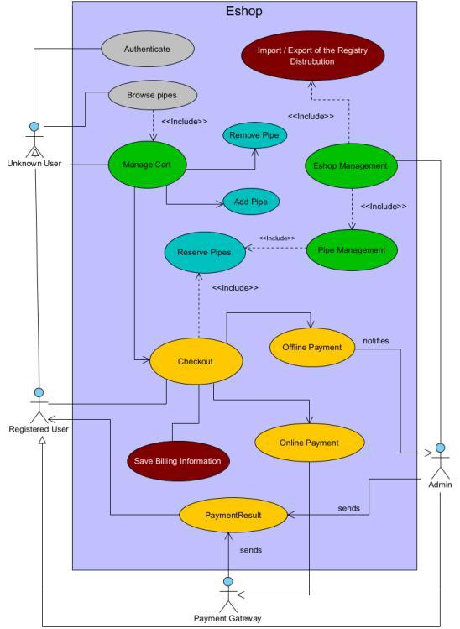

Fig. 3.1. Use Case Diagram of the implemented e-shop

Use cases describe the behavior of the system when an actor performs an action. These use cases are within the system boundary, which represents the system itself. Anything within the boundary is considered internal to the system, while anything outside of it is external. Additionally, associations represent the

32

relationships between the components. Figure 3.1 displays the Use Case Diagram for the system in this study

**3.1.2 *Database diagram***

In order to handle the data effectively, it needs to be stored in a database. For this project, PostgreSQL, a relational database, has been chosen. To model the database can be utilized and it is not a part of the UML, it is widely used for designing data structures and database systems [22]. It plays a similar role to the Class Diagram but specifically focuses on database design. It is highly favored as it helps avoid design errors, such as creating tables that contain unnecessary information. The Database Diagram for the e-commerce platform can be observed in Figure 4.2.

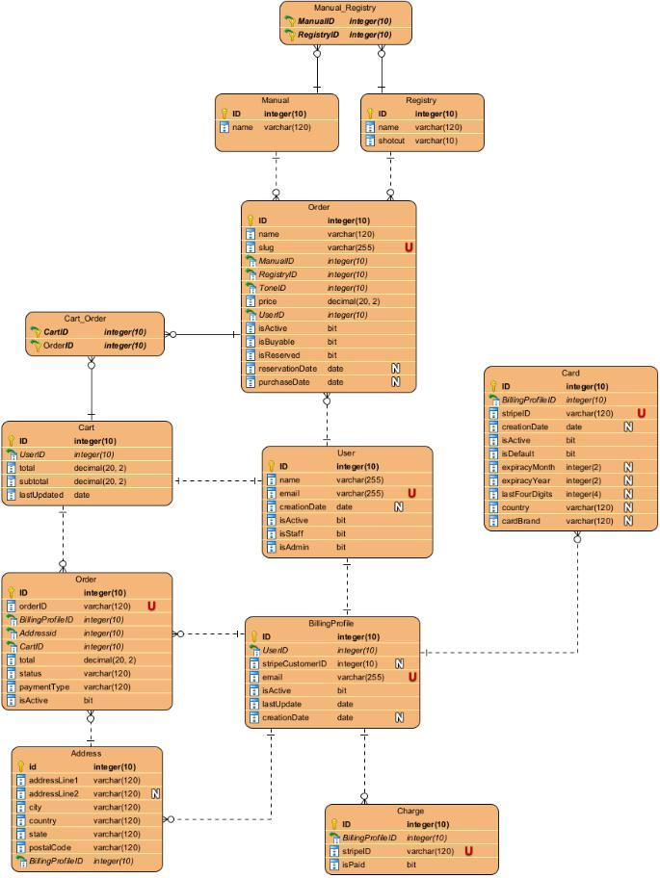

Fig. 3.2. Database diagram of the implemented e-shop **3.1.3 *Project architecture***

The project structure is a key aspect in understanding the project and facilitating navigation. Fortunately, Django provides a well-defined project structure that organizes each app into separate Python packages. This structured

33

approach enables efficient collaboration, even for individuals who are not familiar with the project. In the provided directory structure, the project is named "my_project_with_apps" and consists of two apps: "my_empty_app" and "cart_app." The project directory contains three packages, including the ones for the apps and a package with the same name as the project. The package with the project name contains different files compared to the app folders. Notably, the settings.py file within this package contains crucial configurations for the website, such as the list of apps being used. It is essential to add apps to the settings.py file for them to function correctly. Moreover, settings.py includes information about the database, allowed hosts, and other important settings.

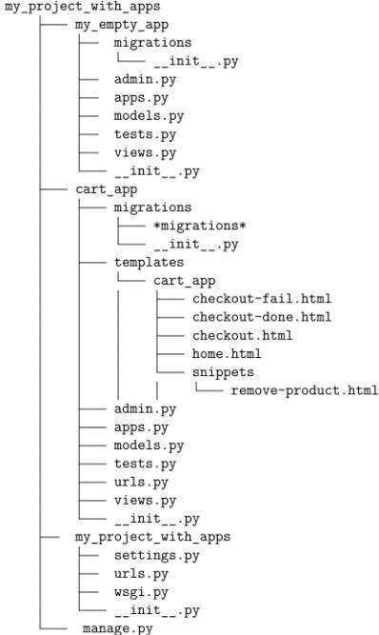

Fig. 3.3. Project architecture

Additionally, there is a significant contrast between "my_empty_app" and "cart_app." The "cart_app" features a template directory that houses the HTML files related to the app. For instance, in code snippet, the view representing the shopping cart can be observed. Towards the end of the code snippet, where the template rendering occurs, it is evident that the templates folder acts as the root directory for accessing the relevant HTML files.

def cart_home_view ( request ) :

cart , _ = Cart . objects . new_or_get ( request )

request . session [’cart_items ’] = cart . pipes . count ()

34

return render ( request , " cart_app / home . html ", {" cart ": cart })

**3.1.4 *Immediate Payments using Stripe***

Once the user has reviewed all the provided information and proceeded to make a payment, the website initiates the payment process through Stripe, a payment gateway. Based on Stripe's response, the user is then redirected to either the success or fail endpoint. If the response indicates a successful transaction, the products are marked as purchased, and website users can view the name of the adoptive user in the details of the purchased products.

Furthermore, Stripe generates a unique Stripe ID for each user, which is utilized to securely store and process credit card information for payment execution. It is important to note that the credit card information is exclusively stored within Stripe's database and is not accessible to the website administrator, except for limited details such as the last four digits of the card, card brand, expiration month, and year. These details are only used to assist the user in confirming the card being used for the transaction.

**3.1.5 *Delayed Payment Methods***

The checkout process and payment via Stripe, the website offers users the option to reserve products using different payment methods. One of the supported methods is a money transfer to the adoption account, which can be done online or offline.

It's important to note that money transfers between accounts may take up to three days, and there may be limitations on the number of API calls per day. To avoid potential issues, a transaction check is performed every 24 hours. The API is used to retrieve account transactions, allowing access to up to 24 months of transaction history. However, for the purposes of the e-shop's check frequency, the transaction history is reduced to 30 days.

To schedule API calls at specific times, a task scheduler is required. While Django does not provide a built-in task scheduler, an external scheduler such as Django-cron can be used. Django-cron allows developers to run Django/Python code on a recurring basis by creating management commands. These commands

35

need to be added to the cron, which is the UNIX system scheduler responsible for executing commands or scripts at predetermined times.

It's worth mentioning that the API requires the admin to log into the account using a link provided during the setup phase. API has access to the account information for 90 days. Some admins may prefer to perform the transaction check independently to avoid the need to regain access every 90 days [23].

In addition to online payments, the admin also handles offline payments, such as cash payments. This requires admin access to the Admin Panel, which provides the ability to make changes to the adoption website. The Admin Panel, depicted in Figure 3.4, grants access to all database-related information and allows the admin to modify it as needed.

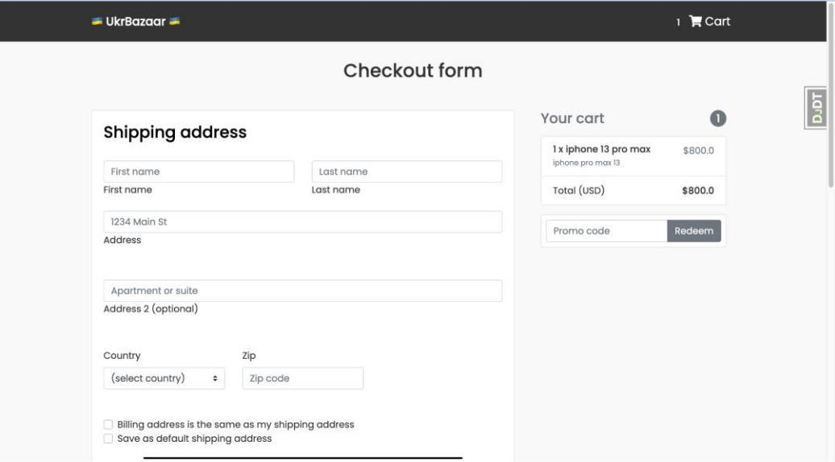

Fig. 3.4. The e-shop design of the checkout review component, where can be seen an address, desired organ pipes, and payment information

**3.2 Data synchronization**

**3.2.1 *Database***

In Django-based e-commerce project, database play a crucial role in storing and managing data. They hold essential information about users, items, orders, payments, and more. The database ensures that data is organized and easily accessible, facilitating efficient operations and a smooth user experience.

The models.py file in Django allows users to create database tables by defining Python classes that inherit from django.db.models.Model. Each model

36

class represents a specific table in the database and defines the fields and behaviors of the data stored within it.

There are various field types available in Django, such as BinaryField, BooleanField, CharField, DateField, DecimalField, EmailField, and many more. Each field type may have optional field options like max_length, primary_key, foreign_key, choices, on_delete, etc., which provide additional functionality and constraints to the fields. These field options may require specific arguments to be passed to them for proper functioning.

Typically, a single class in models.py corresponds to a single database table. It is recommended to override the str function within a class to provide a more meaningful representation of the objects in the Django admin panel. By default, if the str function is not overridden, the objects will be displayed as '<class name> object', which may not be very informative. Overriding the str function improves readability and makes it easier to identify objects in the admin panel. class Customer(models.Model):

customer_id = models.BigAutoField(primary_key=True)

lastname = models.CharField(max_length=64)

middlename = models.CharField(max_length=64, null=True)

firstname = models.CharField(max_length=64)

phone = models.CharField(max_length=64, null=True)

socialnumber = models.IntegerField(null=True)

customer_date = models.DateTimeField(auto_now_add=True, null=True)

def __str__(self):

return f'{self.lastname} {self.middlename} {self.firstname}'

Migrations in Django are used to manage changes to the database models, such as adding or deleting rows, modifying fields, or altering table structures. It is necessary to perform migrations whenever there are changes made to the models.

$ python manage.py makemigrations

$ python manage.py migrate

37

Optionally, models can be registered in the admin interface to provide a convenient way for developers to manage and edit data. Each Django app has an admin.py file specifically designed for this purpose. By registering models in the admin.py file, developers can gain an overview of the data and easily perform CRUD operations.

To register a model in the admin interface, developers can pass the model classes as arguments to the admin.site.register() function. This configuration allows the Django Admin page to display and provide editing capabilities for the registered models, such as the Customer objects, within their respective detail pages.

from .models import *

admin.site.register(Customer)

By utilizing the admin interface, developers can efficiently manage the data associated with the registered models, making it a recommended practice to enhance the administration and manipulation of data within the Django project.

Additionally, the Django administration site presents tables for the registered and created apps, offering a comprehensive view of the models associated with each app. This provides a centralized location for administrators to interact with and manipulate the data stored within the Django project.

**3.2.2 *Admin Panel***

In order to import or generate a registry disposition, users need to be authenticated as admins. If a user without admin permission tries to access the website, they will encounter an "access denied" or "page not found" error. This restriction is in place because manipulating the e-shop can have significant consequences, and to ensure stability, only admins are allowed to perform tasks related to importing or exporting registry dispositions. Admins have access to the admin panel. The admin panel provides an overview of all existing models and allows the admin to manipulate the data within them. These models are predefined in the models.py file of each application in the project. An example of such a model can be seen in the code snippet results and in Figure 3.5.

38

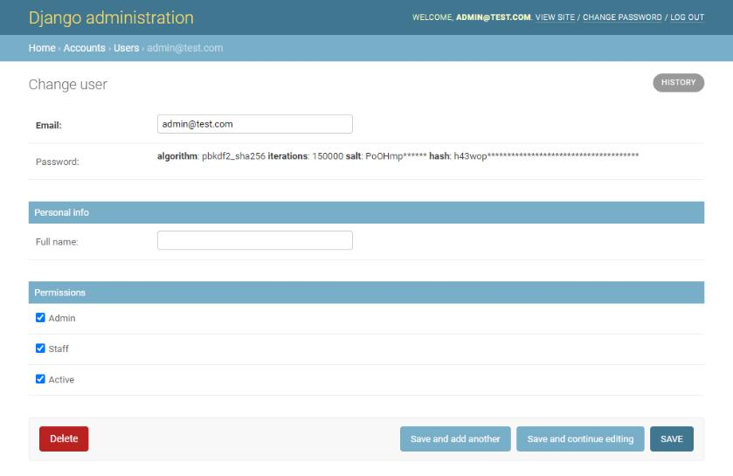

Fig. 3.5. A single user model displayed in admin panel with the data modification class User ( AbstractBaseUser ) :

email = models . EmailField ( unique =True , max_length =255 , blank = False )

full_name = models . CharField ( max_length =255 , blank = True , null = True )

active = models . BooleanField ( default = True )

staff = models . BooleanField ( default = False )

admin = models . BooleanField ( default = False )

timestamp = models . DateTimeField ( auto_now_add = True )

Furthermore, the Admin panel serves as a tool for managing offline purchases. When a customer buys a product in person or through a bank transfer, the admin can conveniently update the selected status and mark it as purchased, along with recording the buyer's provided name. This functionality enables seamless handling of offline transactions within the system.

**3.3 Conclusions of chapter 3**

The development of a web-application for an electronic commerce platform involves various aspects such as design and implementation, as well as data synchronization.

The design and implementation phase focuses on creating an intuitive and visually appealing user interface for the web-application. This includes front-end development using tools like HTML, CSS, and JavaScript to design the layout,

39

colors, fonts, and other visual elements of the application. The front-end developers are responsible for ensuring that the website is user-friendly and provides a seamless navigation experience. On the back-end, server-side tools like Python and frameworks like Django are used to handle data synchronization and communication between the client and server. These tools enable the web-application to interact with databases, process user requests, and perform necessary calculations or operations.

Data synchronization plays a crucial role in ensuring that the information displayed on the web-application remains up-to-date and consistent across different devices and platforms. This involves handling user inputs, updating the database, and propagating changes to all relevant components of the application. Tools like APIs and task schedulers are utilized to automate and manage these synchronization processes effectively.

The development of a web-application for an electronic commerce platform requires a combination of front-end and back-end development tools, effective data synchronization techniques, and a well-designed user interface. The successful implementation of these elements ensures a smooth and efficient user experience while interacting with the electronic commerce platform.

40

**4.****ANALYSIS OF THE DEVELOPED WEB-APPLICATION 4.1 Implementation of the web-application**

**4.1.1 *Settings up development environment***

The primary objective of this project is to develop a simple Django application for a fabric business, providing the business owner with a convenient way to manage their operations. The application aims to streamline business processes by implementing a database to store customer information, fabric rolls, and orders, all within an intuitive and user-friendly interface. By utilizing this application, the shop owner can serve customers more efficiently by quickly searching for desired fabric rolls in the database. Furthermore, the application helps reduce paperwork and document management, as all relevant information is stored electronically.

Although this web application is basic in nature, it is crucial to address the specific challenges and requirements of the fabric business. The project goals include features such as customer, product, and order listings, a robust security system, and the ability to perform Create, Read, Update, and Delete (CRUD) operations on the stored data.

Before initiating the development process, it is essential to set up the development environment. In this thesis project, the development environment will be set up on a Windows 10 operating system. While it is possible to configure the environment on other operating systems, the process may differ. Therefore, it is advisable to refer to the application's documentation for specific instructions based on the respective operating system.

The Django framework will be hosted on a lightweight Linux environment using Docker. To begin, several programs need to be installed, although the installation steps may vary depending on the operating system. The required programs include Python 3.11.1, pip, Django framework, Docker Desktop, and GitHub Desktop.

41

To ensure compatibility and avoid conflicts between different versions of Django and their dependencies, a Python Virtual Environment will be utilized during the project's development. This virtual environment provides an isolated environment, keeping the various Django versions separate. The following code snippet, "Code 1," demonstrates how to create a virtual environment in the current directory. The command creates a target directory, which can be named (in this case) "venvdjango." Within the directory, there will be a file named "pyvenv.cfg" and three subdirectories: "Include," "Lib," and "Scripts."

By setting up the development environment properly, the project can proceed smoothly, ensuring a consistent and reliable foundation for building the Django application.

$ python -m venv venvdjango

The following command will activate the Virtual Environment that was created using the command above.

$ venvdjango\bin\activate

To install Django version 4.1.5 within the activated Virtual Environment, you can use the following command. The command utilizes pip, which is a Python package installer and manager.

pip install Django==4.1.5

Once Django is successfully installed, you can create a new Django project by executing the following command:

django-admin startproject UkrBazzar

This command will automatically generate the necessary files and directory structure for your Django project, including settings, database configurations, and application settings. The newly created project will be named " UkrBazzar ".

**4.1.2 *Django app development***

Django provides developers with the capability to create individual apps within a project. This feature is crucial for organizing and isolating different functionalities or components of a website or application. For instance, in an e-commerce website, separate apps can be created for user authentication, payment

42

processing, and product listing. This approach simplifies the development and maintenance process for complex projects.

By dividing the project into apps, the codebase becomes more organized and manageable. Each app focuses on specific features or functionalities, allowing for cleaner and more modular code. This also facilitates easier debugging and testing, as issues can be isolated to specific apps rather than affecting the entire project.

The diagram below illustrates the concept of creating separate apps within a

Django project:

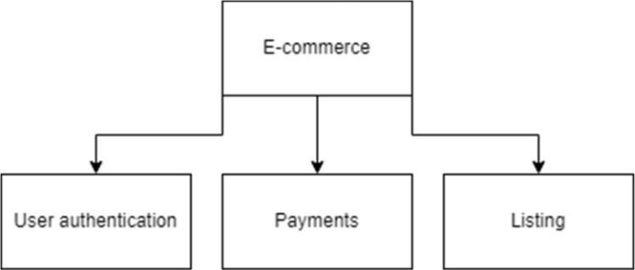

Fig. 4.1. Apps for an e-commerce website.

Every Django project has a base app named after the project itself. In your case, it is located in the directory " UkrBazzar / UkrBazzar ". The files included in the base app are asgi.py, settings.py, urls.py, wsgi.py, and init.py. Among these files, settings.py and urls.py are the main files of interest. settings.py serves as the configuration file for the Django project. It contains important settings and configurations that control various aspects of the project's behavior. For example, you can register installed apps and middleware components within the INSTALLED_APPS and MIDDLEWARE sections, respectively. Additionally, settings related to static files, WSGI application, and database configurations can also be found and configured in this file.

On the other hand, urls.py is responsible for defining the URL patterns and routing within the Django project. It determines how incoming requests are mapped to specific views and handlers. By configuring the URLs in this file, you can define the structure and behavior of different pages and endpoints within your project.

43

These two files, settings.py and urls.py, are vital for the proper functioning and customization of your Django project. They provide a central place for managing project-wide settings and URL routing, ensuring that your application functions correctly and responds to requests as expected.

The INSTALLED_APPS setting in the Django project is a Python list that contains the names of all the apps currently registered within the Django framework. Each app in this list plays a specific role in the project's functionality. In this case, the "Management" app that you created needs to be added to the INSTALLED_APPS list for Django to recognize it and include it in the project.

The STATIC_FILES section is used to configure the handling of static files such as CSS, JavaScript, and images. To define the STATIC_URL, you specify the URL path where these static files will be served from. In your case, the directory "static/" inside the project folder is designated as the location for storing all CSS, JS, and image files.

Here is an example of how the STATIC_URL can be defined in the project's settings.py file:

STATIC_URL = 'static/'

The DATABASES setting is a Python dictionary that contains the database configurations used by Django. By default, the code generated by the Django framework sets up the project to use the SQLite database engine. The NAME parameter specifies the path to the SQLite database file, which in this case is located at BASE_DIR/db.sqlite3. However, depending on the project requirements and developer preferences, this configuration can be changed to use other databases such as MariaDB, MySQL, or PostgreSQL. The ENGINE parameter would be updated accordingly to reflect the chosen database engine.

DATABASES = {

'default': {

'ENGINE': 'django.db.backends.sqlite3',

'NAME': BASE_DIR / 'db.sqlite3',

}

44

**4.1.3 *Creating and install a Django Application***

To create the "management" app, you can use the following command:

$ python manage.py startapp management

This command creates a new app named "management" in the project folder. It generates the necessary files and folders for the app's functionality, such as database configurations, class views, and testing files.

Conventionally, you can create additional files and folders inside the app folder for further development. For example, you can create a "templates" folder to store HTML templates and an "urls.py" file for routing URLs.

After creating the app, you need to register it in the project's settings.py file, which is located in the base app directory created by Django. You can add the app's name to the INSTALLED_APPS list, as shown below:

INSTALLED_APPS = [

'django.contrib.admin',

'django.contrib.auth',

'django.contrib.contenttypes',

'django.contrib.sessions',

'django.contrib.messages',

'django.contrib.staticfiles',

'management',

]

In the above example, the newly created app "management" is added to the INSTALLED_APPS list alongside other Django apps that come with the framework. django.contrib.admin is a powerful automatic admin interface used as an internal management tool. django.contrib.auth is a component of Django's authentication system. django.contrib.contenttypes provides tracking of the models installed within the Django project. django.contrib.sessions can be used for storing and retrieving data on a per-site-visitor basis. django.contrib.messages provides support for flash messages or one-time notification messages. django.contrib.staticfiles collects static files from each application into a single location. By registering the "management" app in the INSTALLED_APPS list, Django will recognize it and include its functionality in the project.

**4.1.4 *Templates and Inheritance***

45

Inheritance in Django allows for the reusability of code by reducing redundancy. This is particularly useful when multiple templates share common elements like the background, navbar, and sidebar. Django provides tags such as {% include %} to include whole files within another file. By using a base template, such as main.html, we can eliminate redundant code such as scripts, navbars, sidebars, and heads.

In the example below, the navbar and sidenavbar are included using the {% include %} tag:

<body class="sb-nav-fixed">

<!-- NAVBAR -->

{% include 'management/navbar.html' %}

<div id="layoutSidenav">

<!-- SIDENAVBAR -->

{% include 'management/sidenavbar.html' %} <div id="layoutSidenav_content"> {% block content %}{% endblock %}

<!-- FOOTER -->

{% include 'management/footer.html' %}

</div>

</div>

This approach results in cleaner code and easier maintenance in the future. Additionally, we use the {% block content %} and {% endblock %} tags to define a block inside main.html for the main content. Since each HTML file may have different main content, but the shared elements like the background and navbar remain the same, we only need to include the main content as a block in the other HTML files.

By using the {% extends %} and {% block %} tags in the specified HTML files, we establish the inheritance and reduce redundancy. For example:

{% extends 'management/main.html' %}

{% block content %}

46

<main>

<!-- main content specific to this HTML file --> </main>

{% endblock %}

With this approach, the specified HTML file extends the main.html template and defines the main content within the {% block content %} and {% endblock %} tags.

**4.1.5 *URL Routing***

The Django framework provides a main urls.py file in the main app to handle URL routing. However, it is common practice to manually create a urls.py file within the management app and include it back in the main urls.py file for easier maintenance.

In the example below, the main app's urls.py file (UkrBazzar/urls.py)

includes the management app's urls.py file:

urlpatterns = [

path('admin/', admin.site.urls),

path('', include('management.urls'))

]

The urlpatterns in the management app's urls.py file (management/urls.py) is a list of paths. When a URL is matched with a path, it triggers a corresponding function. For example:

urlpatterns = [

path("home", views.home, name="home"),

path("charts", views.charts, name="charts"),

path("customerTable", views.customerTable, name="customerTable"),

path("productTable", views.productTable, name="productTable"),

path("orderTable", views.order, name="orderTable"),

]

In this case, the "orderTable" URL will trigger the "order" function in views.py. This function retrieves data from the Order table in the database and

47

returns an HTML response. The data retrieved, in this case, is a SQL query result from the Order table.

def order(request):

order = Order.objects.all()

context = {

'order': order,

}

return render(request, 'management/tables/orderTable.html', context)

The context variable contains the retrieved data, and it is passed to the orderTable.html template for rendering.

**4.1.6 *Identification, authentication, and authorization***

A security system ensures that only authorized users can access the system by verifying their identity through authentication and determining their privileges for certain actions through authorization. In the Django framework, authentication-related functionality is provided by the django.contrib.auth module, which includes methods like authenticate(), login(), and logout(). These methods can be imported into views.py to handle the identification, authentication, and authorization logic.

To restrict unauthorized access and allow only authenticated users to log in, the login_required() decorator can be used. This decorator checks if the user is logged in or not and redirects them to the login page if necessary. Otherwise, it renders the view normally.

@login_required(login_url="login")

To implement the login logic, the following code snippet (Code 26) can be used. It retrieves the username and password from a POST request, uses the authenticate() API to verify the credentials, and either redirects the authenticated user to the homepage or displays an error message on the login page.

@unauthenticated_user

def login(request):

if request.method == "POST":

username = request.POST.get("username")

48

password = request.POST.get("password")

user = authenticate(request, username=username, password=password)

if user is not None:

login(request, user)

return redirect("home")

else:

messages.info(request, "Incorrect username or password.")

context = {}

return render(request, "management/login.html", context)

To address the issue of authenticated users accessing the login page, the unauthenticated_user decorator can be used. This decorator checks if the user is authenticated and redirects them to the homepage if so. Otherwise, it allows the execution of the view_func, which is the login() function in this case.

def unauthenticated_user(view_func):

def wrapper_func(request, *args, **kwargs):

if request.user.is_authenticated:

return redirect("home")

else:

return view_func(request, *args, **kwargs)

return wrapper_func

For authorization, Django provides groups that can be assigned to users. By defining the allowed_users decorator, which takes a list of allowed_roles, certain pages can be restricted based on group membership. The decorator checks if the user belongs to a group specified in the allowed_roles list and renders the view if the conditions are met. Otherwise, it returns a HttpResponse with a message indicating the lack of permission.

def allowed_users(allowed_roles=[]):

def decorator(view_func):

def wrapper_func(request, *args, **kwargs):

group = None

49

if request.user.groups.exists():

group = request.user.groups.all()[0].name if group in allowed_roles:

return view_func(request, *args, **kwargs)

else:

return HttpResponse("You don't have permission to access this

page.")

return wrapper_func

return decorator

Creating and assigning groups can be done through the Django Admin Panel, which is accessible to superuser accounts. It can be accessed at "/admin" ("http://127.0.0.1:8000/admin").

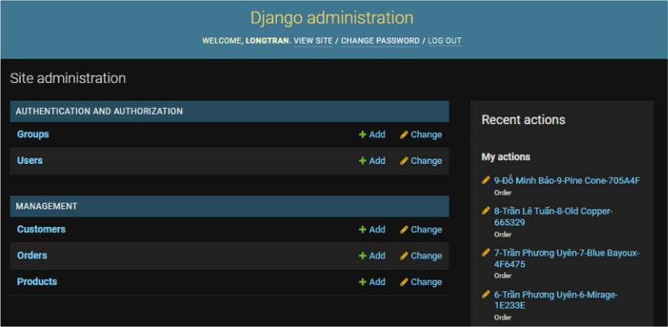

Fig. 4.2. The Django administration.

After importing the necessary decorators into views.py, the allowed_users decorator can be used by specifying the authorized group names with @allowed_users(allowed_roles=[]). For example, the home function can be restricted to users within the "admin" group using the login_required and allowed_users decorators.

@login_required(login_url="login") @allowed_users(allowed_roles=["admin"]) def home(request):

customer = Customer.objects.all()

order = Order.objects.all()

product = Product.objects.all()

50

total_customer = customer.count()

total_order = order.count()

total_product = product.count()

context = {

"customer": customer,

"order": order,

"product": product,

"total_customer": total_customer,

"total_order": total_order,

"total_product": total_product,

}

return render(request, "management/index.html", context)

With the above code, only users in the "admin" group will have access to the home function and be able to view the site. Other users will be redirected to the login page if they attempt to access it.

**4.2 Testing of the web-application**

**4.2.1 *Testing Django application***

The use of web applications ensures that customers always have access to the latest version of the services. This delivery mechanism aligns well with agile development processes. The web application utilize Django, one of the most popular web frameworks in Python. Django, maintained by The Django Software Foundation and released under an Open Source BSD license, empowers developers to build high-quality web applications quickly and with minimal code. It promotes rapid development and follows a clean, pragmatic design philosophy. Django emphasizes automation and adheres to the DRY (Don't Repeat Yourself) principle.

Django's popularity extends to numerous companies and organizations worldwide, making it a widely adopted framework. The insights gained from this case study can potentially be extrapolated to other software projects utilizing Django. Django offers several valuable components for web application development. Of particular relevance to this report are the following features:

51

Model-View-Controller-like (MVC) Pattern: Django employs a variation of the MVC pattern. Models are represented as Python classes tightly coupled to relational database models and managed by an Object-Relational Mapper (ORM). Views consist of Python callback functions associated with specific URLs, defining the data to be presented. The presentation of data is handled by a powerful templating system that separates content from presentation. The controller, responsible for URL dispatching, can be configured using regular expressions.

Additional Powerful Features: authentication, caching, logging, email sending, session handling, and data validation. Django also includes tools for mitigating common security issues in web applications, such as cross-site request forgery, cross-site scripting, SQL injection, and password cracking.

Django's close integration with relational databases significantly contributes to the rapid development facilitated by the framework. Developers can leverage the full capabilities of the database through the convenient ORM provided by Django. However, this tight coupling presents challenges, which will be addressed in the next section along with potential solutions.

In software testing, isolating test case executions is crucial to achieve commutative behavior, where the order of execution does not impact the results. Clearing the relational database, along with related caches, between test executions can provide isolation for small components. However, for comprehensive system testing, resetting the entire database between tests is not feasible. The application, with its extensive database usage and complex data structures, requires a more efficient approach.

Django offers a solution through its test framework. The standard Python implementation of the xUnit testing pattern, unittest.TestCase, is extended by Django with additional functionality in django.test.TestCase. One of the key features is the wrapping of each test execution in a database transaction, which is rolled back at the end of each test. This approach efficiently isolates test cases, minimizing the time between tests from minutes to fractions of a second.

52

While django.test.TestCase minimizes the time between test runs, it does not reduce the cost of initializing the entire system at startup. To address this, LBTest, the testing tool used in this case study, follows a different approach. The SUT (System Under Test) process is started once and remains active throughout the testing session, eliminating the need to restart it for each test. This necessitates a new method of sending input commands from LBTest to the SUT.

**4.2.2 *Client/Server adapter***

To facilitate communication between LBTest and the SUT (System Under Test), an adapter is used. The adapter converts symbolic inputs from LBTest into native actions for the SUT, interprets the state of the SUT, and communicates the state back to LBTest encoded as a bit vector. The adapter is implemented as a client/server architecture consisting of two parts.

The server-side of the adapter allows the SUT to be a long-running process. It communicates with the client-side of the adapter, which is repeatedly created and terminated, using a standard TCP network socket. This architecture enables efficient and reliable communication between LBTest and the SUT. The communication protocols are depicted in figure 4.3.

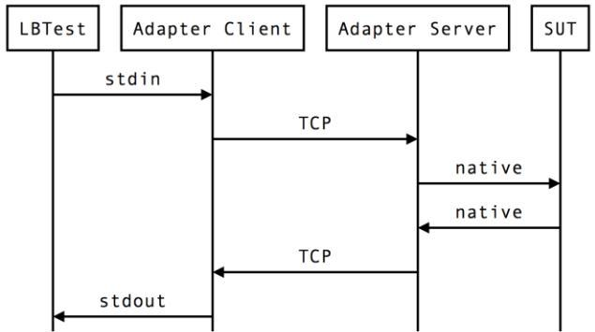

Fig. 4.3. Sequence diagram describing the communication protocols.

It is important to note that in these experiments, both the TCP server and client were running on the same host, communicating through the localhost loopback address. This means that the communication did not involve any physical network devices and relied on the link layer of the TCP/IP stack, making it an efficient communication channel.

The general data flow between the components can be described as follows:

1. The System Under Test (SUT) is started.

53

1. Once initialized, the SUT waits for incoming TCP connections, blocking its execution.
2. LBTest is started and the experiment is set up.
3. When the "Start Testing" button is clicked in LBTest, the adapter client is executed.
4. LBTest sends input symbols to the adapter client through the stdin stream.
5. The adapter client establishes a TCP connection with the adapter server and transmits the input symbols.
6. The adapter server interprets the input symbols as native SUT actions, performs them, and responds to the adapter client with the SUT state encoded as a bit vector.
7. The adapter client writes the bit vector to LBTest through stdout.
8. LBTest proceeds with another SUT execution, repeating the process from step 4.

To ensure the reproducibility of this case study for other Django projects, the implementation details of the SUT adapter are provided in the following sections. These details include the client implementation.

The client implementation of the adapter is quite small. On Unix systems, all the necessary tools for implementing the adapter client are already built-in and come with the operating system. In this case study, the client is implemented as a Bash script, as shown in the following listing.

#!/bin/bash

set -e

echo "Waiting for a Word"

read INPUT_SYMBOLS

BITVECTOR=$(echo $INPUT_SYMBOLS | nc localhost 4711)

echo $BITVECTOR

The adapter client script begins by sending a readiness message to LBTest through stdout, indicating its preparedness to receive input. Subsequently, the script retrieves input from stdin and assigns it to the INPUT_SYMBOLS variable.

54

This variable's contents are then piped to the nc program (netcat). Netcat, functioning as a TCP utility, forwards the input symbols to the specified destination host (localhost) and port (4711). The response received from the adapter server is saved in the BITVECTOR variable. Finally, the adapter client script sends the BITVECTOR back to LBTest for further processing.

The server-side implementation of the LBTest SUT adapter in Django is provided in the code snippet below:

import socket

import unittest

from django.test import TestCase

from django.test.utils import setup_test_environment from django.core.management.base import BaseCommand

def evaluate(commands):

* Evaluate all commands and return the SUT state as a bit vector string.
* Implementation specific to the SUT.

def evaluate_with_rollback(commands):

def eval_in_test_context(_):

global output_bitvector

output_bitvector = evaluate(commands)

MyTestCase = type('MyTestCase', (TestCase,), dict(runTest=eval_in_test_context))

test = MyTestCase()

unittest.TextTestRunner().run(test)

return output_bitvector

55

def create_socket():

server_socket

=

socket.socket(socket.AF_INET,

socket.SOCK_STREAM)

server_socket.setsockopt(socket.SOL_SOCKET,

socket.SO_REUSEADDR, 1)

server_socket.bind(('127.0.0.1', 4711))

server_socket.listen(5)

return server_socket

def accept_incoming_connections(server_socket):

while True:

connection, _ = server_socket.accept()

socket_file = connection.makefile()

line = socket_file.readline().strip().decode('utf-8')

bitvector = '%s\n' % evaluate_with_rollback(line)

connection.sendall(bitvector)

connection.shutdown(1)

connection.close()

class Command(BaseCommand):

def handle(self, *args, **options):

setup_test_environment()

server_socket = create_socket()

accept_incoming_connections(server_socket)

The handle method in the Command class, defined on line 46, sets up the test environment and starts listening for incoming TCP connections. Line 38 reads a line of commands sent from an adapter client, which is then passed to the

56

evaluate_with_rollback function on line 13. This function plays a crucial role in efficiently testing Django applications with LBTest. The evaluate_with_rollback function dynamically generates new test classes using the type function call, leveraging the built-in support for database rollbacks after each test run provided by django.test.TestCase.

The evaluate function is implementation-specific and depends on the actual SUT. In this case study, various methods for executing specific SUT actions were successfully tested, such as using django.test.client.Client as a dummy web browser or directly accessing the ORM to change the state of the SUT.

**4.2.2 *Eliciting software requirements***

The SUT was executed in its entirety, but it doesn't mean that all functionality of the entire codebase was tested. In a large SUT, the success of using LBTest relies on the person setting up the tests and implementing the adapter. LBTest only executes the input commands implemented in the adapter and has knowledge of the output from the adapter. Therefore, the success of the testing process depends on finding combinations of inputs and outputs that allow the tester to express well-formulated LTL properties as software requirements. This process involves three steps:

1. Eliciting informal requirements.
2. Choosing a suitable input alphabet and output data types from the SUT's large domain.
3. Converting the informal requirements into formal LTL requirements based on the chosen input alphabet and output data types.

Choosing the inputs and outputs to and from the adapter is a way of modeling the SUT. One could argue that creating this model is what LBTest was expected to do automatically. However, the manual step is more like defining the boundaries of the system and allowing LBTest to automatically fill in the missing parts.

Authentication addresses the problem of determining the identity of a user. Authorization deals with determining whether an authenticated user is allowed to

57

perform a specific operation. A feature-rich user authentication system is a central component of any Django application. The critical aspect is deciding the permissions and actions available to users within the system. A simplified view of user authorization can be described as follows: A user belongs to a party, which represents a legal entity. Additionally, there are user accounts for staff. To participate in a compression cycle, a program must have the appropriate protocol adherence stored in the system. The protocol can be seen as a legally binding contract between program parts. Only staff users have the authority to add or remove protocol adherences for programs. The testing conducted using LBTest in this study focused on these important aspects, as they form the foundation for subsequent operations in the system.

**4.2.3 *Test execution***

During the test executions in this study, LBTest was configured to stop testing after five hypothesis equivalences. Different maximum run times were applied, ranging from 1 hour to 8 hours. The hardware and software used, as well as the approach to collecting results. LBTest was an early version with limited documentation and verbose error messages. To ensure the case study's success, proper logging of important data collected during the study was crucial. During execution, LBTest reported errors and other information on stdout and stderr. Understanding how the tool worked and diagnosing issues relied on this information. A script, as shown in the listing, was employed to capture and store all this information in time-stamped files for each execution of LBTest.

#!/bin/bash

set -e

DATE=$(date +’%Y-%m-%d_%H-%M-%S’) echo $DATE > start_date.txt LOGFILE=lbtest-output.$DATE.log java -jar lbtest.jar 2>&1 > $LOGFILE

The script captures the current timestamp and stores it in the DATE variable. It then creates a file named start_date.txt and writes the timestamp to it. After that,

58

it executes the LBTest tool, redirecting both the stdout and stderr outputs to a log file with a name like "lbtest_output.2013-02-25_13-37.txt".

To gain insight into the communication between LBTest and the SUT adapter, a minor modification was made to the adapter Client. The modified source code is provided in the following listing.

#!/bin/bash

set -e

echo "Waiting for a Word"

read INPUT_SYMBOLS

BITVECTOR=$(echo $INPUT_SYMBOLS | nc localhost 4711)

echo $BITVECTOR

LBTEST_START_DATE=$(cat start_date.txt) LOGFILE=sut-io.$LBTEST_START_DATE.log DATE=$(date +’%Y-%m-%d_%H-%M-%S’)

echo "$DATE: $LINE => $BITVECTOR" >> ../$LOGFILE

The modified source code includes logging capabilities. They append the conversation between LBTest and the SUT adapter, timestamped with the date of LBTest execution, to a file with the execution date included in its name.

A LBTest testing sessions were conducted, and comprehensive data was collected, including log files, screenshots of the GUI at various execution stages, detailed versions of the SUTs and their respective adapters, state graphs, test verdicts, and additional comments.

**4.3 Conclusions of chapter 4**

Implementation of the web-application: The chapter focused on the implementation of the web-application, highlighting the various components, modules, and functionalities that were developed. It discussed the technologies and frameworks used, as well as the architectural design decisions made. Overall, the implementation was successful in achieving the desired features and functionality.

Testing of the web-application: The chapter also covered the testing phase of the web-application. It described the different types of testing conducted, such as

59

unit testing, integration testing, and system testing. The testing process aimed to identify and address any bugs, errors, or issues in the application. Through rigorous testing, many potential issues were discovered and resolved, ensuring the stability and reliability of the web-application.

The analysis of the developed web-application demonstrated that it was effectively implemented, incorporating the desired features and functionality. The testing phase played a crucial role in identifying and resolving potential issues, resulting in a stable and reliable web-application. These findings contribute to the overall success of the development process and lay the foundation for future improvements and enhancements.

60

**CONCLUSIONS**

The web application for the electronic commerce platform was created with a user-friendly interface that enables seamless online shopping experiences for customers and facilitates effective management of the platform for business owners. Throughout the project, a combination of HTML, CSS, and JavaScript was used for frontend development, while Python and SQLite were employed for backend implementation.

The choice of HTML, CSS, and JavaScript for frontend development proved to be effective in creating a user-friendly and visually appealing interface. These technologies allowed for the seamless integration of various design elements and the implementation of interactive features, enhancing the overall user experience.

On the backend, Python and SQLite were selected as the primary technologies. Python provided a solid foundation for handling the application's business logic and server-side operations, while SQLite proved suitable for managing and storing the application's data.

The successful integration of these technologies resulted in a well-rounded web application for the electronic commerce platform. The application offers essential features such as product catalog management, shopping cart functionality, payment integration, and order processing. These features collectively contribute to a seamless and convenient online shopping experience for customers.

61

**LIST OF REFERENCES**

1. Vincent, W. S. Django for Beginners: Build Websites with Python and Django. Welcometocode, 2020. – 292 p.
2. George, N. Build a Website with Django 3: A Complete Introduction to Django
   1. GNW Independent Publishing, 2021. – 262 p.
3. Pinkham, A. Web Development in Python with Django: Building Backend Web Applications and APIs with Django. Pearson Education, Limited, 2019. –
   1. p.
4. Bendoraitis, A., Kronika, J. Django 3 Web Development Cookbook: Actionable Solutions to Common Problems in Python Web Development, 4th Edition. Packt Publishing, Limited, 2020. – 608 p.
5. Uzayr, S. B. Mastering Django: A Beginner's Guide. CRC Press LLC, 2022. –
   1. p.
6. Ravindran, A. Django Design Patterns and Best Practices: Easily Build Maintainable Websites with Powerful and Relevant Django Design Patterns. Packt Publishing, Limited, 2015. – 222 p.
7. Smith, D. Python Machine Learning: The Crash Course for Beginners to Programming and Deep Learning, Artificial Intelligence, Neural Networks and Data Science. Scikit Learn, Tensorflow, Pandas and Numpy. Independently published, 2019. – 142 p.
8. Korper, S. The E-commerce book: Building the E-empire. San Diego : Academic Press, 2000. – 284 p.
9. Moore A. Create your own online store in a weekend. 2014. – 176 p.
10. J M. R. Electronic commerce. 4th ed. New York, NY : Aspen Publishers, 2011. – 894 p.
11. Mourya S. K. E-Commerce. Alpha Science International, Limited, 2015. –
    1. p.
12. Electronic Commerce 2008 (Electronic Commerce) / P. Marshall et al. Prentice Hall, 2007. – 1008 p.

62

1. Stewart, S. Python Programming: Python Programming for Beginners, Python Programming for Intermediates. Platinum Press LLC, 2019. – 180 p.
2. Bennett, J., Overland, B. Advanced Python Programming. Pearson Technology Group Canada, 2019. – 672 p.
3. Liang, Y. D. Programming. Pearson Education, Limited, 2012. – 768 p.
4. Crispin, L. Testing Extreme Programming. Boston : Addison-Wesley, 2003. –

306 p.

* 1. Software Testing Techniques: Finding the Defects that Matter (Programming Series) / G. Miller et al. Charles River Media, 2004. – 362 p.

1. Python [Electronic resource]. – Access mode: https://docs.python.org/3/tutorial/
2. Python web framework Django [Electronic resource]. – Access mode: https://www.djangoproject.com/
3. E-commerce Website using Django [Electronic resource]. – Access mode: https://www.geeksforgeeks.org/e-commerce-website-using-django/
4. LBTest: A Learning-Based Testing Tool for Reactive Systems [Electronic

resource]. – Access mode:

https://www.semanticscholar.org/paper/LBTest%3A-A-Learning-Based-

Testing-Tool-for-Reactive-Meinke-

Sindhu/c3be7eafa7e203690df3606b6279e8e2b5de2470

1. Testing Safety Critical Avionics Software Using LBTest [Electronic resource].

– Access mode: https://www.semanticscholar.org/paper/Testing-Safety-Critical-Avionics-Software-Using-Stenlund/0822e41416154fd2301f0dbadd30f41bfc1c2582

1. Testing in Django [Electronic resource]. – Access mode: https://realpython.com/testing-in-django-part-1-best-practices-and-examples/

63

**APPENDICES**

64

**Appendix 1**

**Database structure**

65

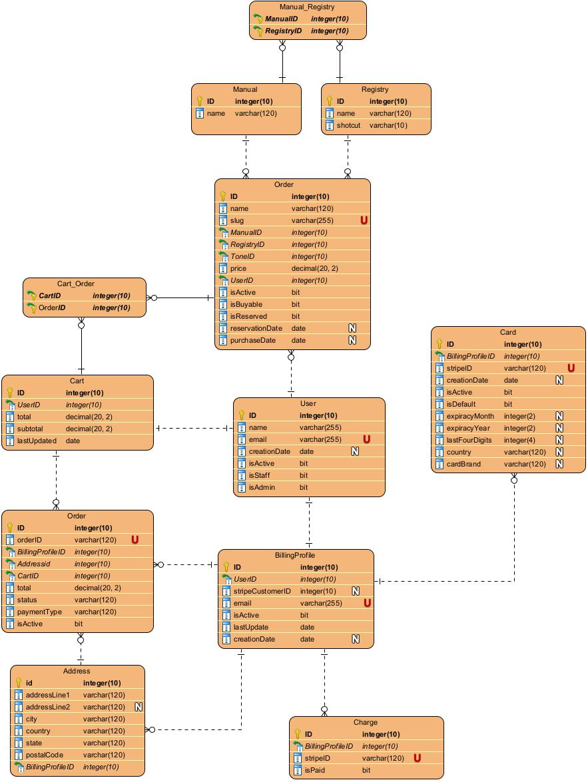

66

**Appendix 2**

**Entity-relationship diagram**

67

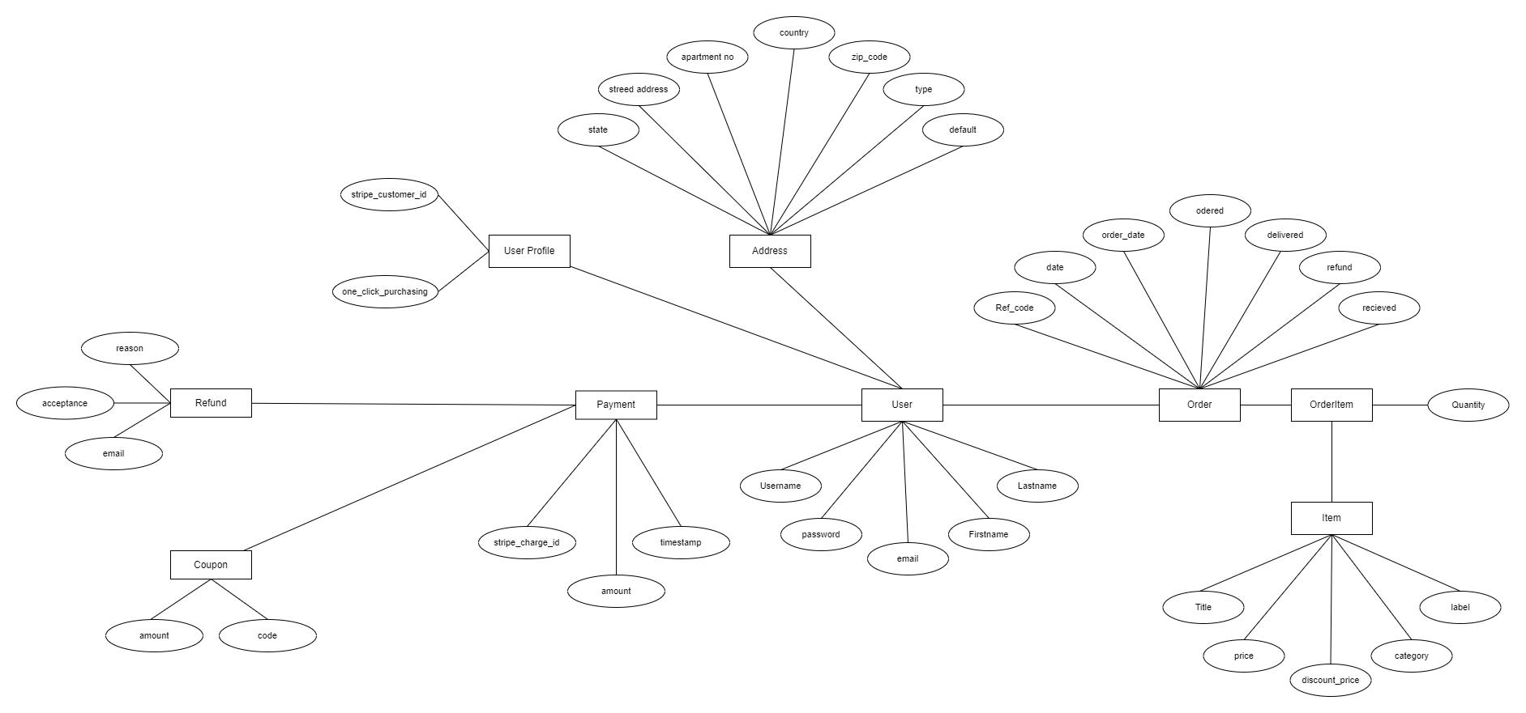

68

**Appendix 3**

**Copy of presentation**

69



70

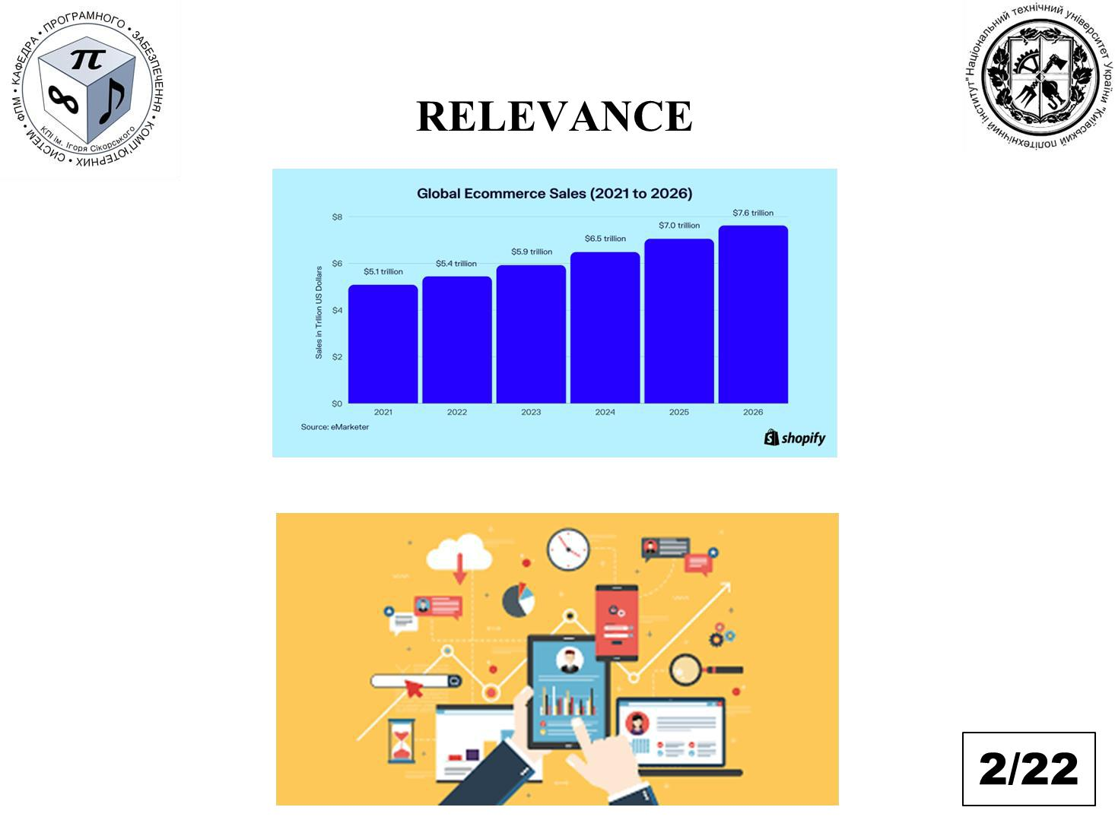

71



72

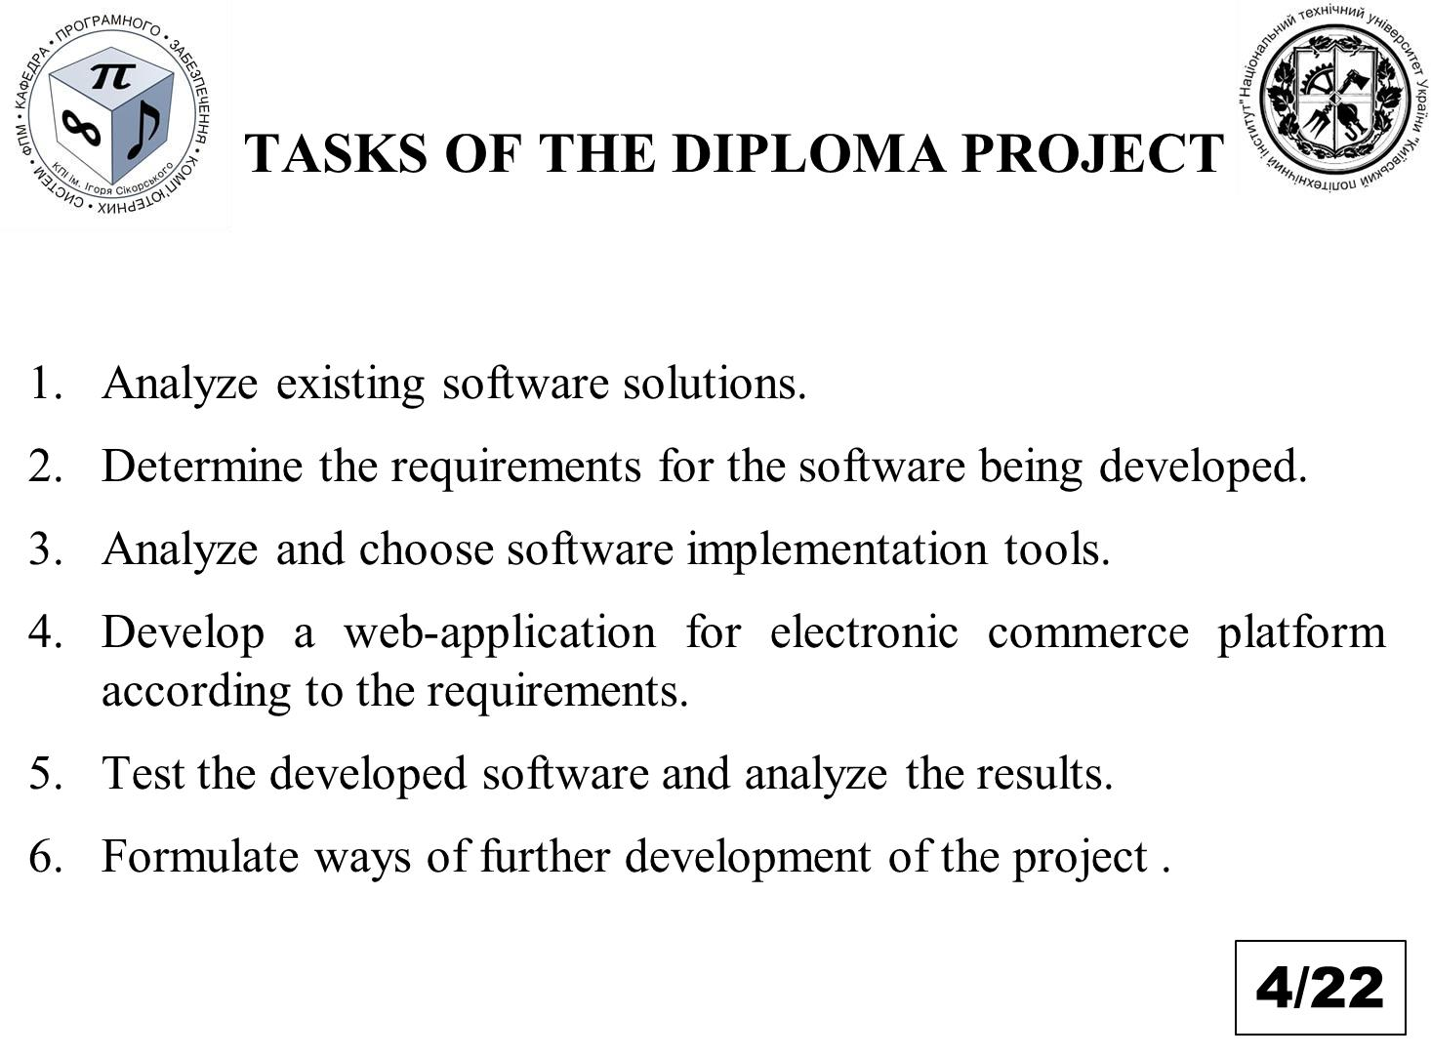

73

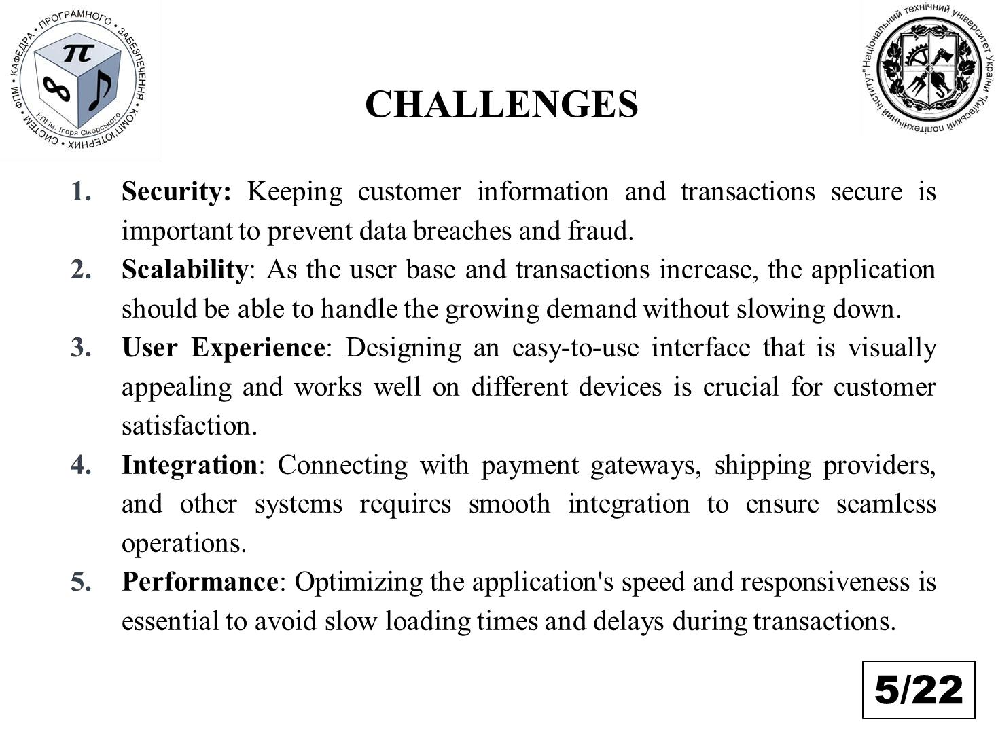

74

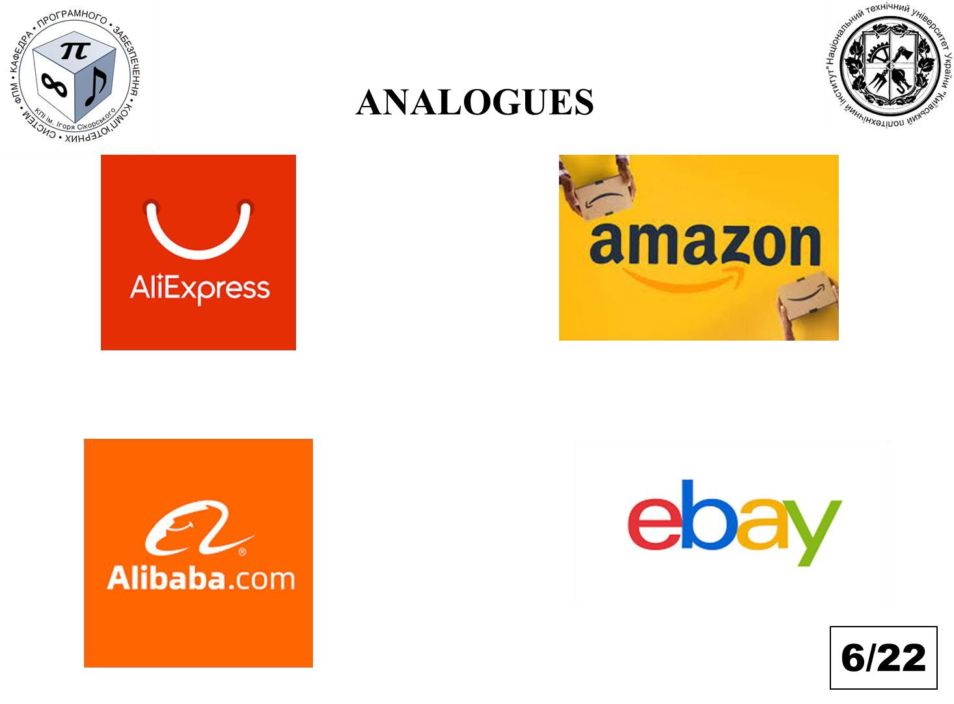

75

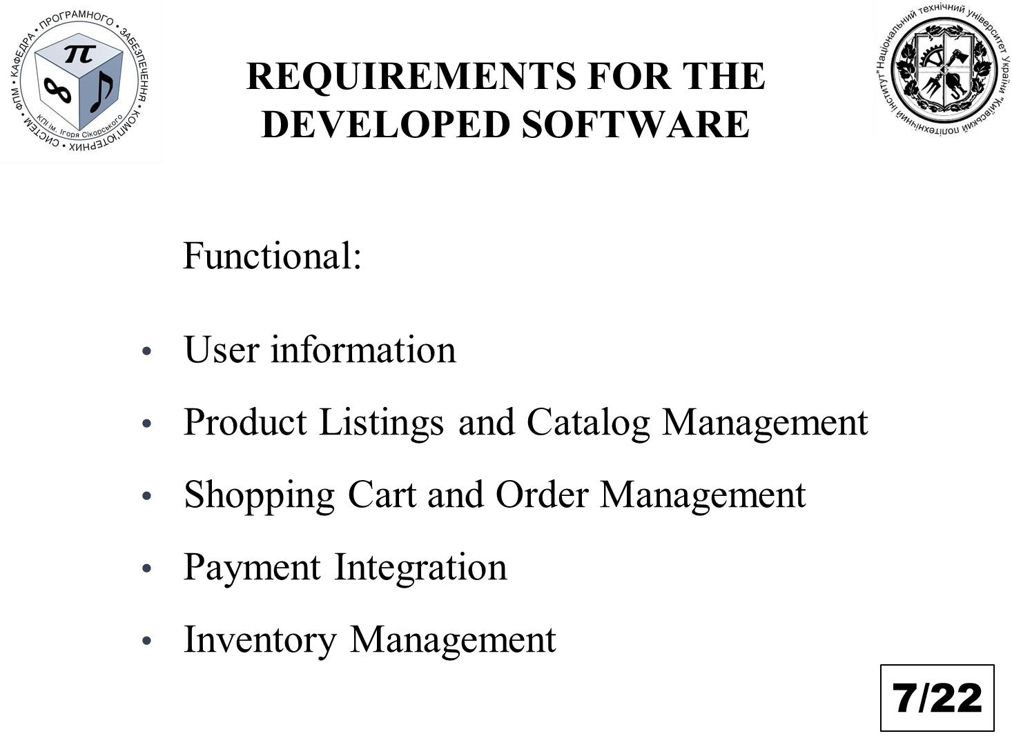

76

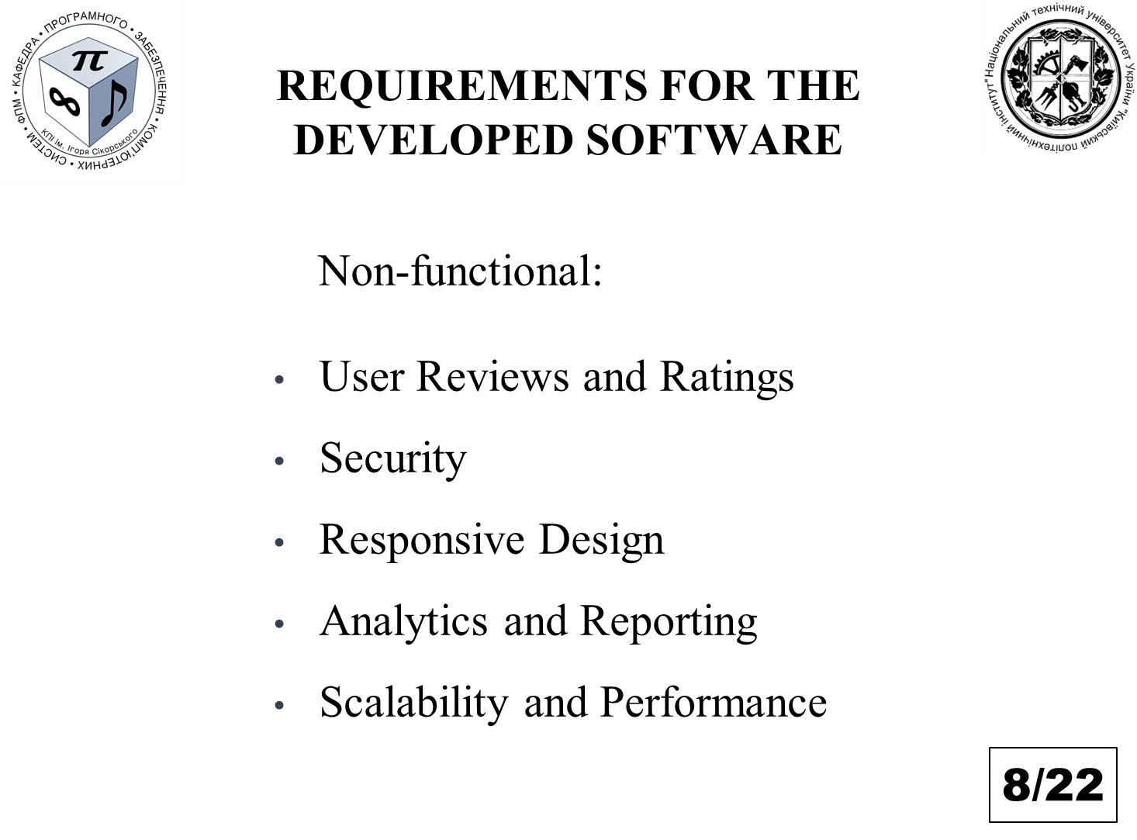

77



78

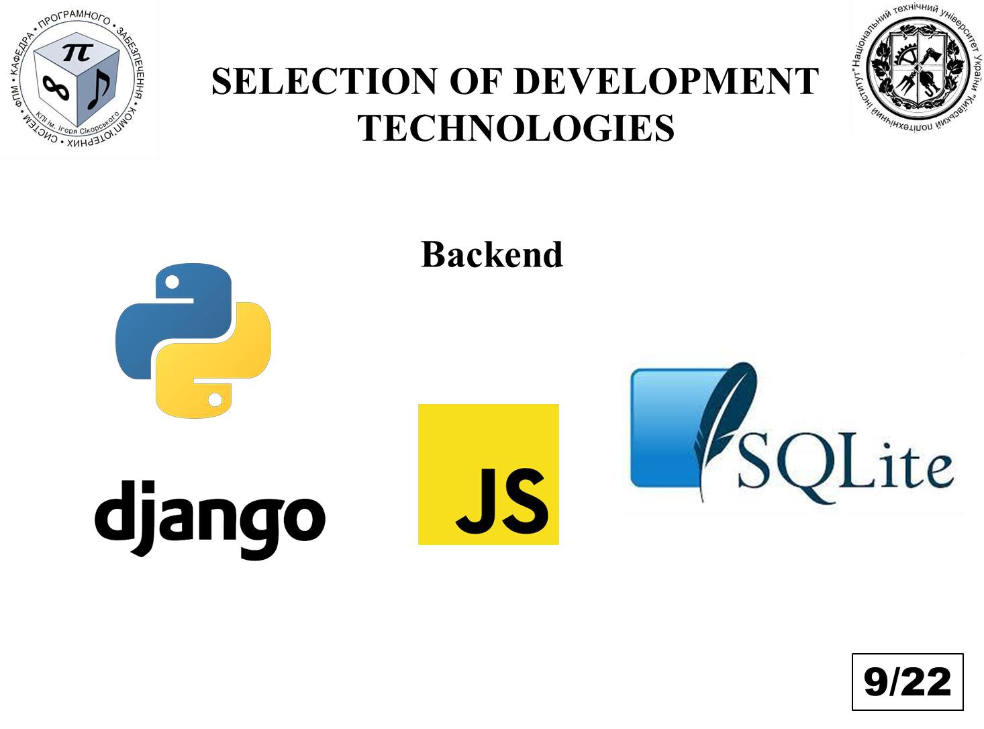

79

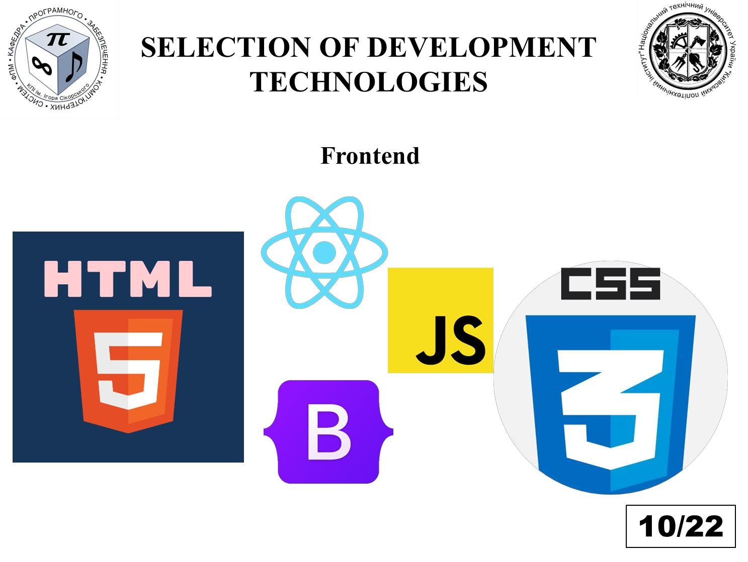

80

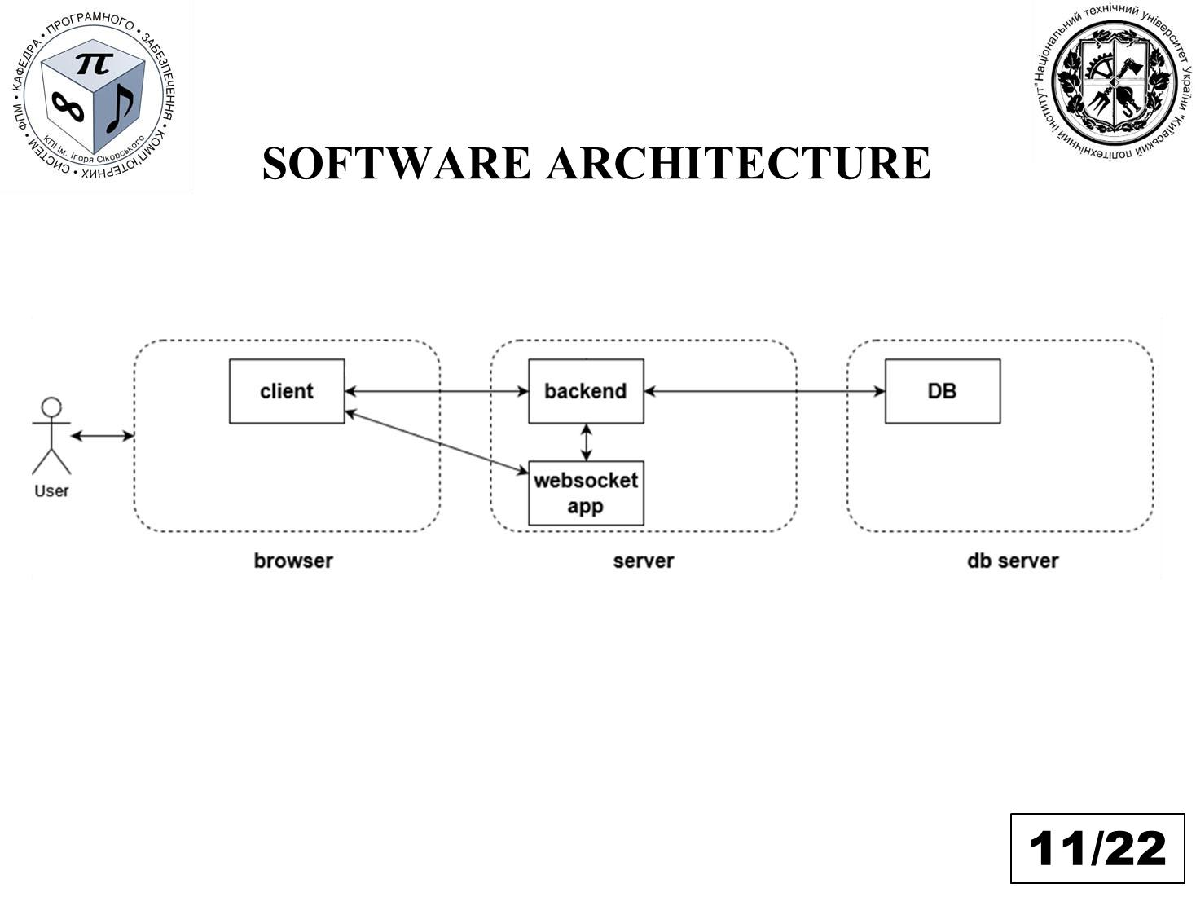

81

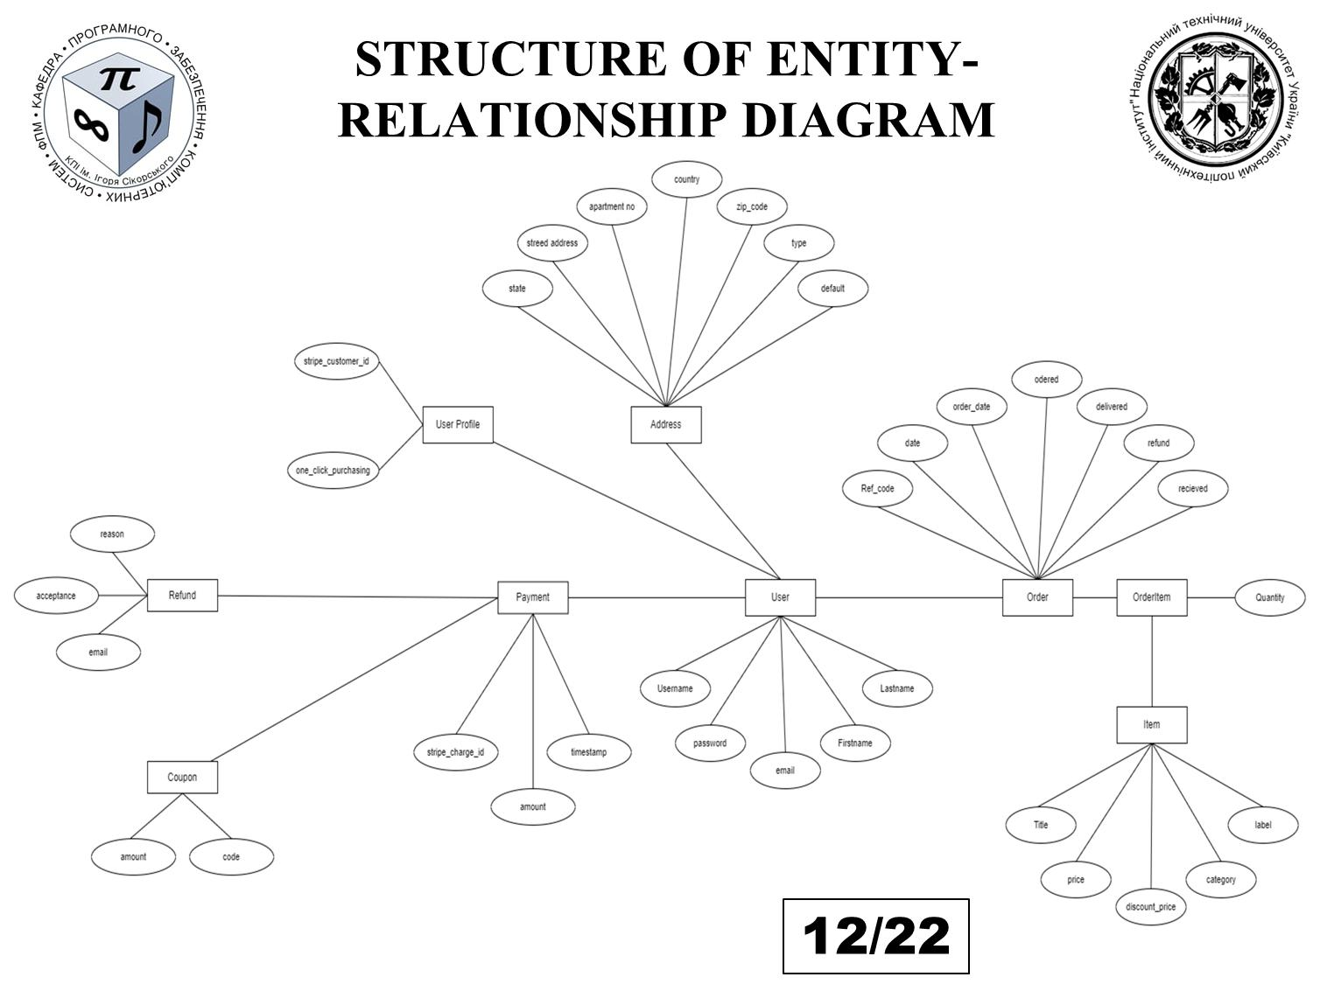

82

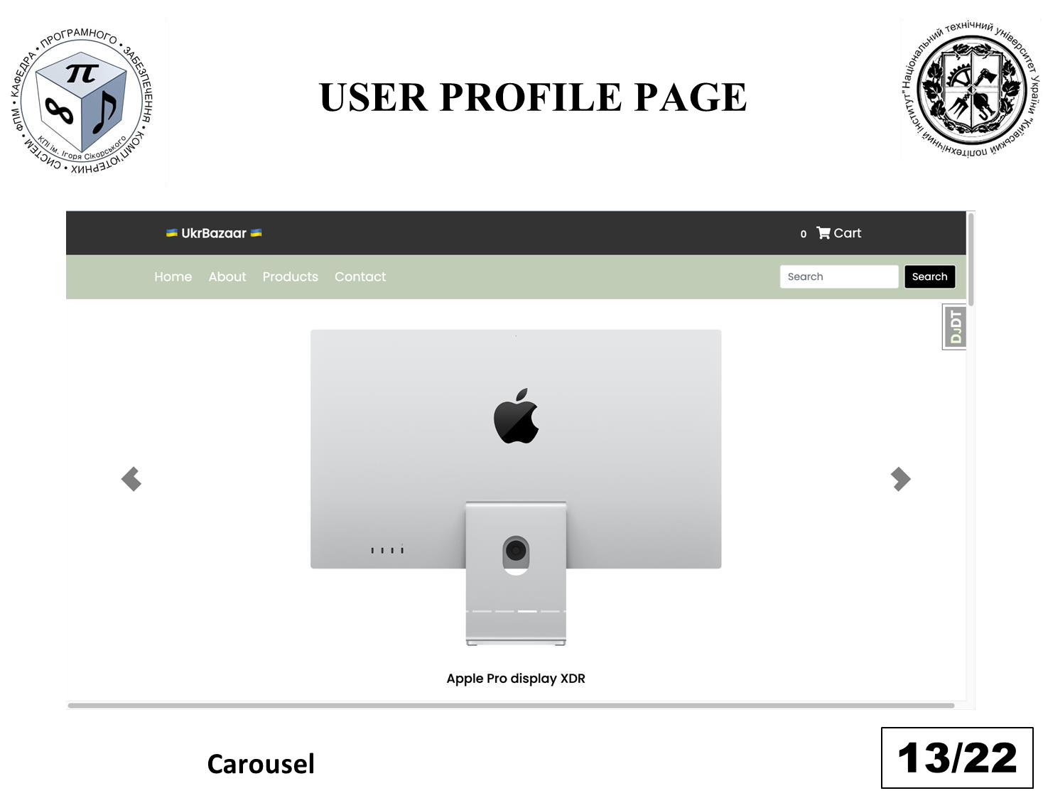

83

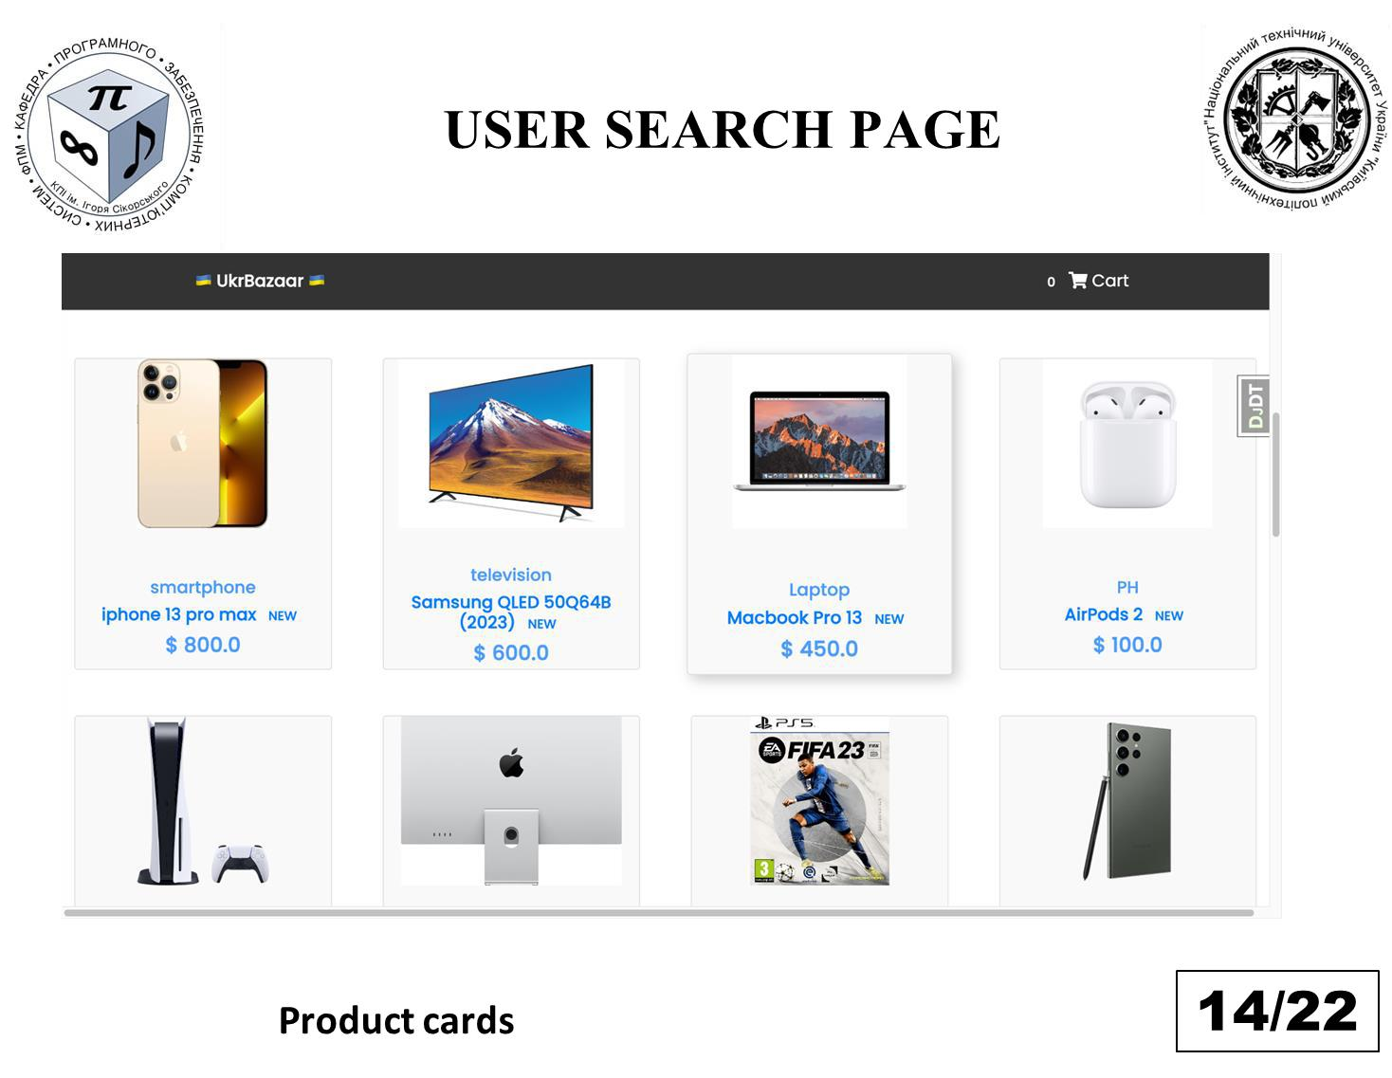

84

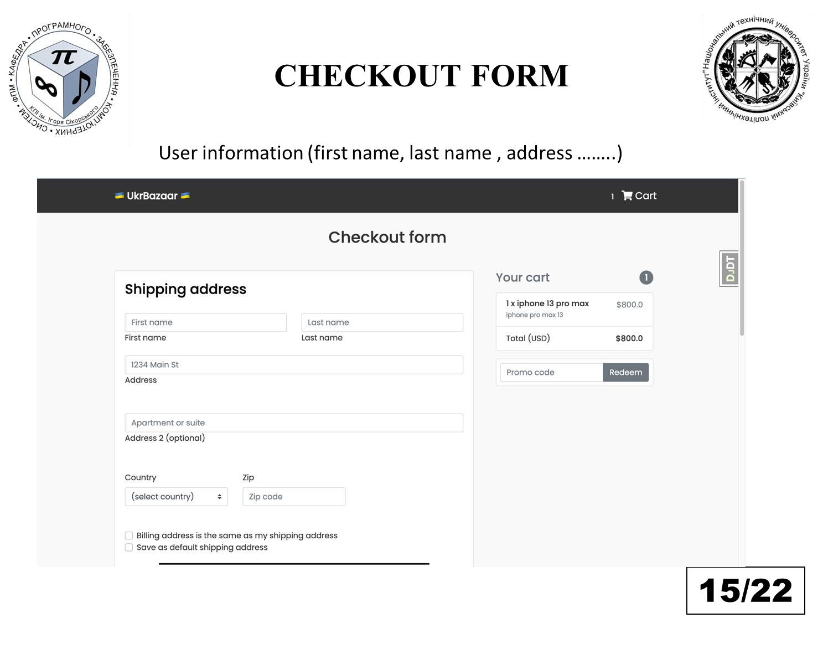

85

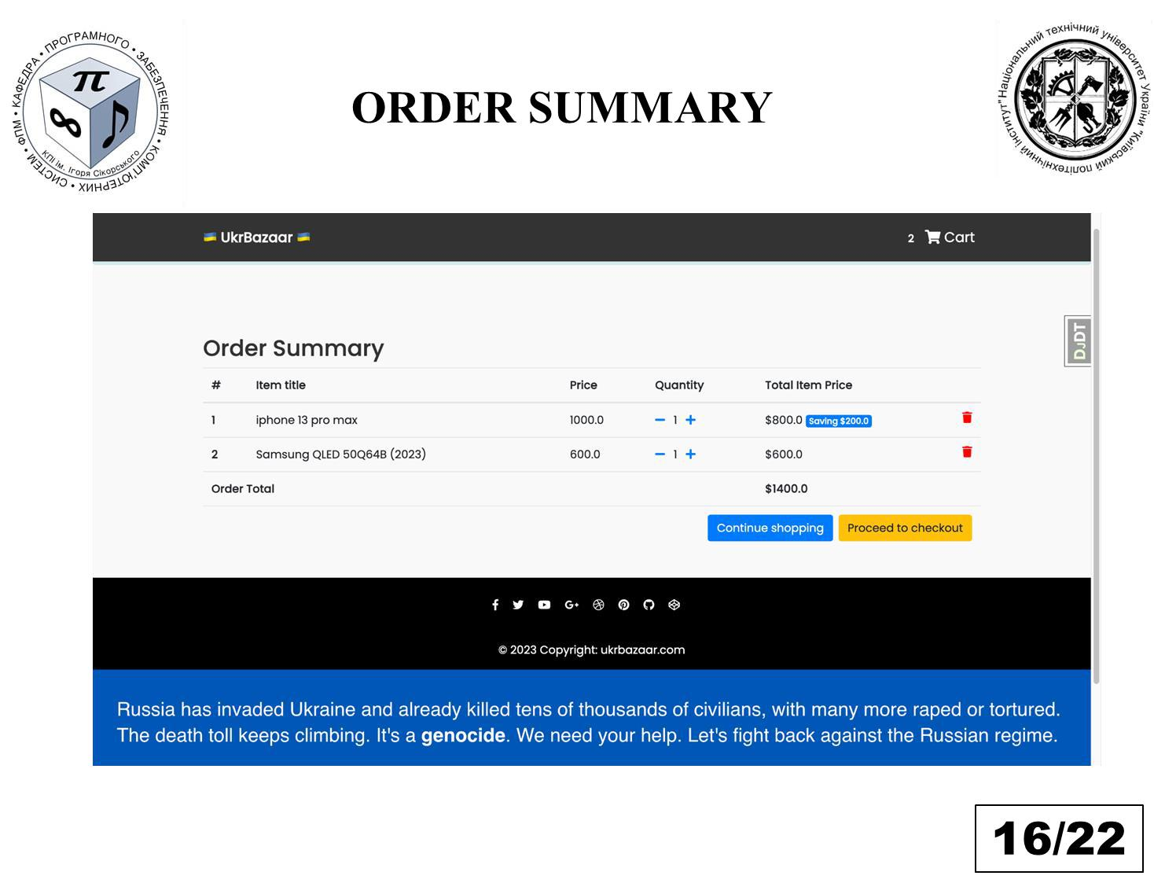

86

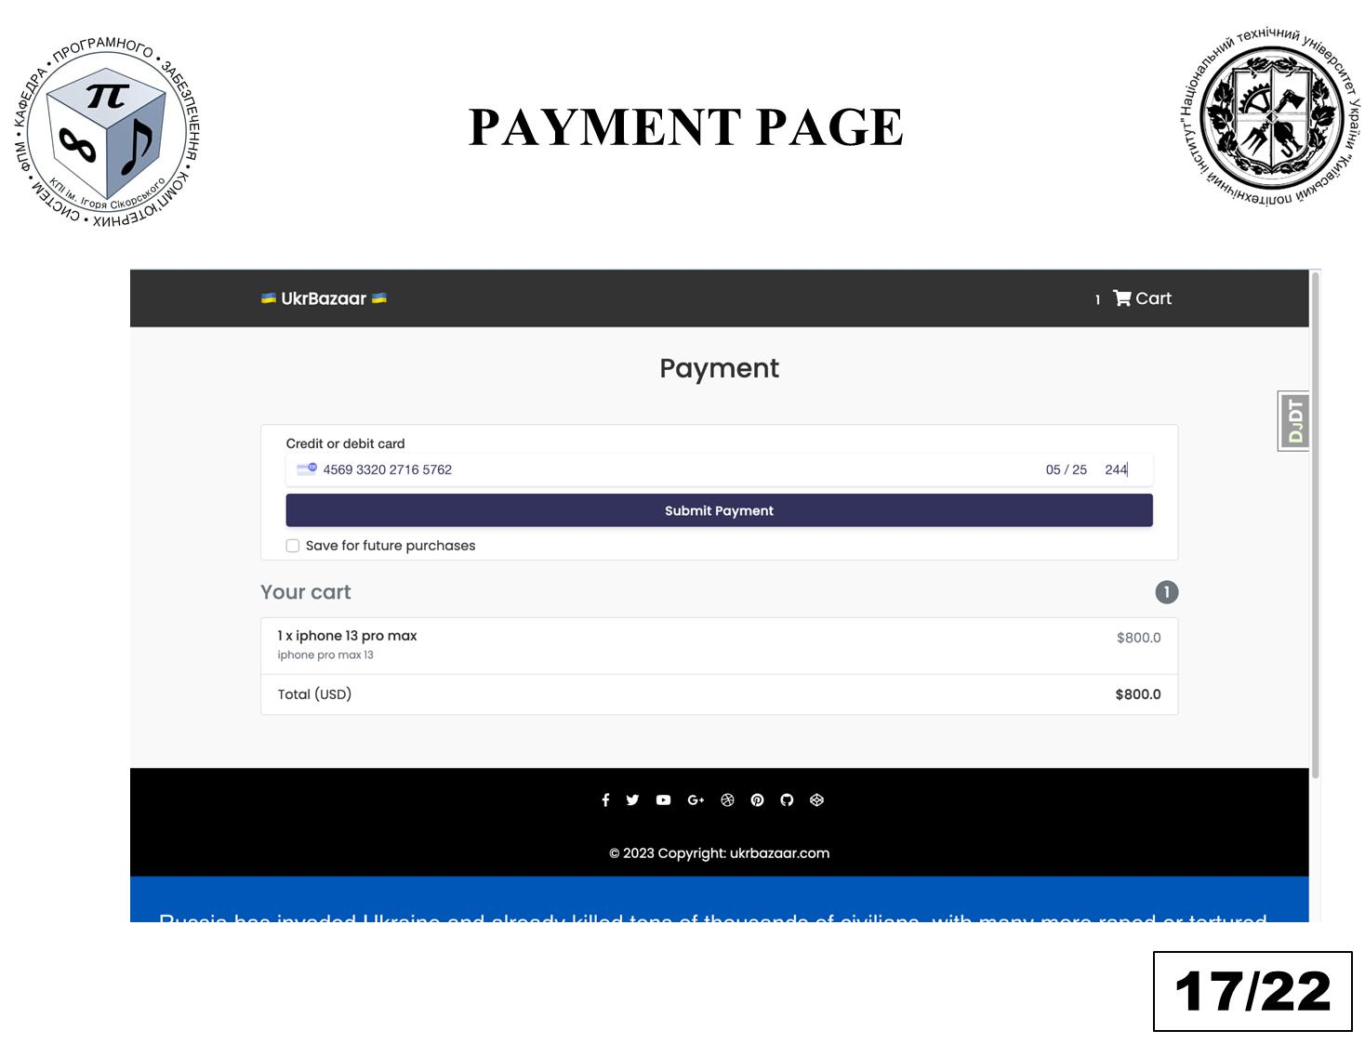

87

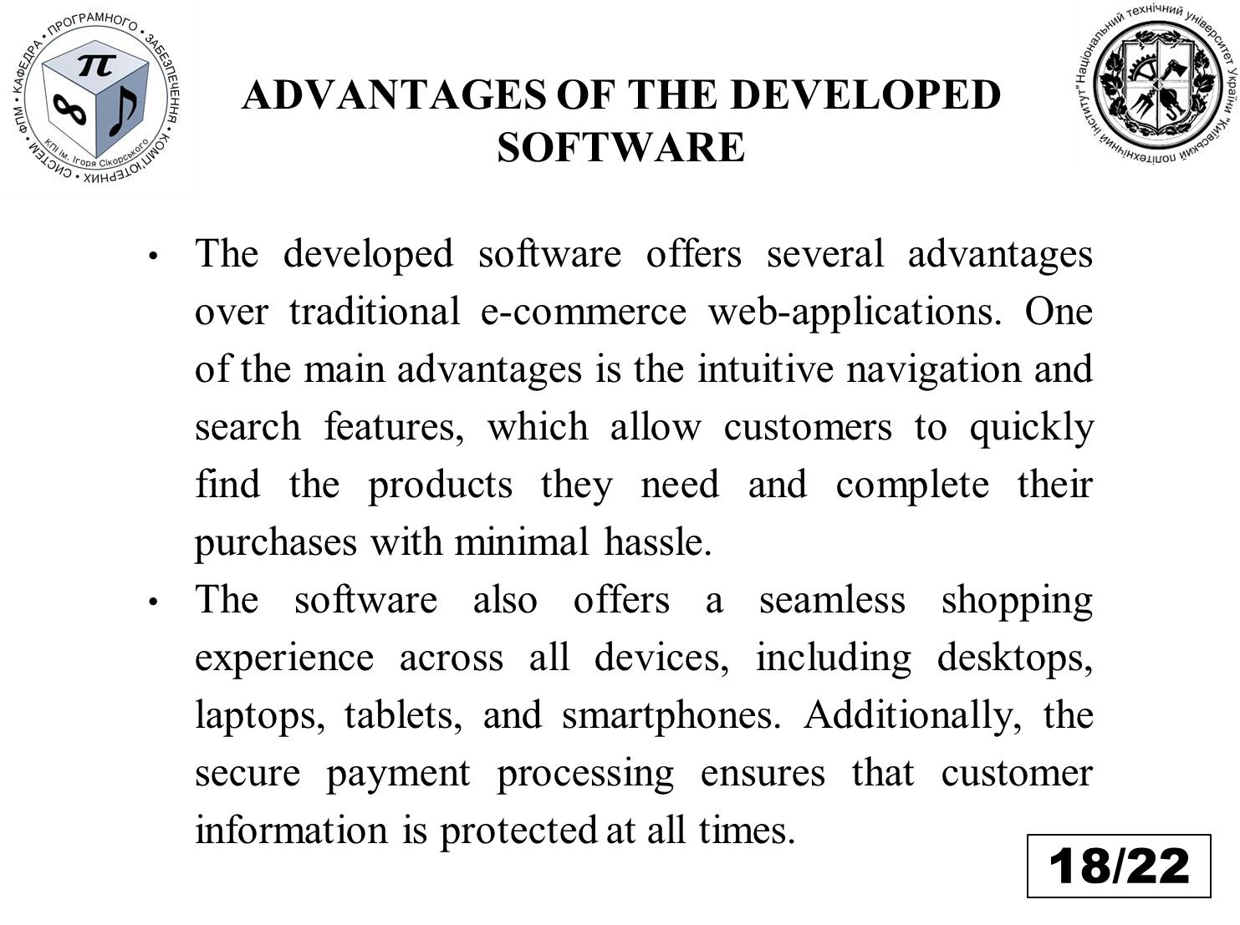

88

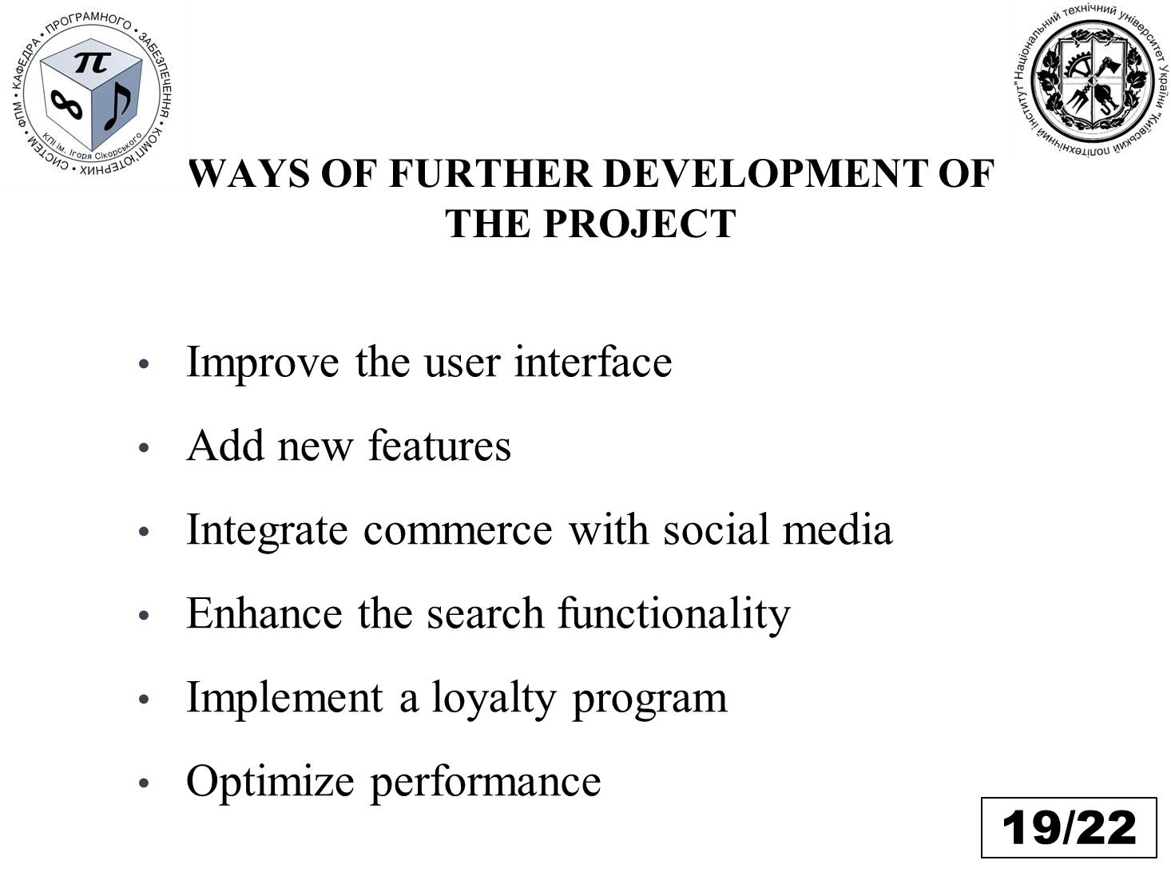

89

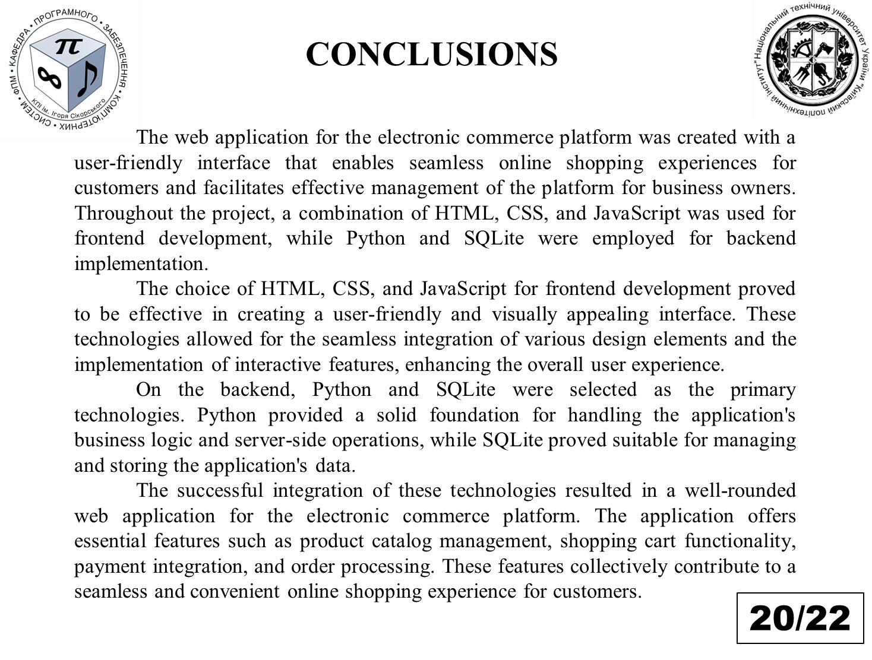

90

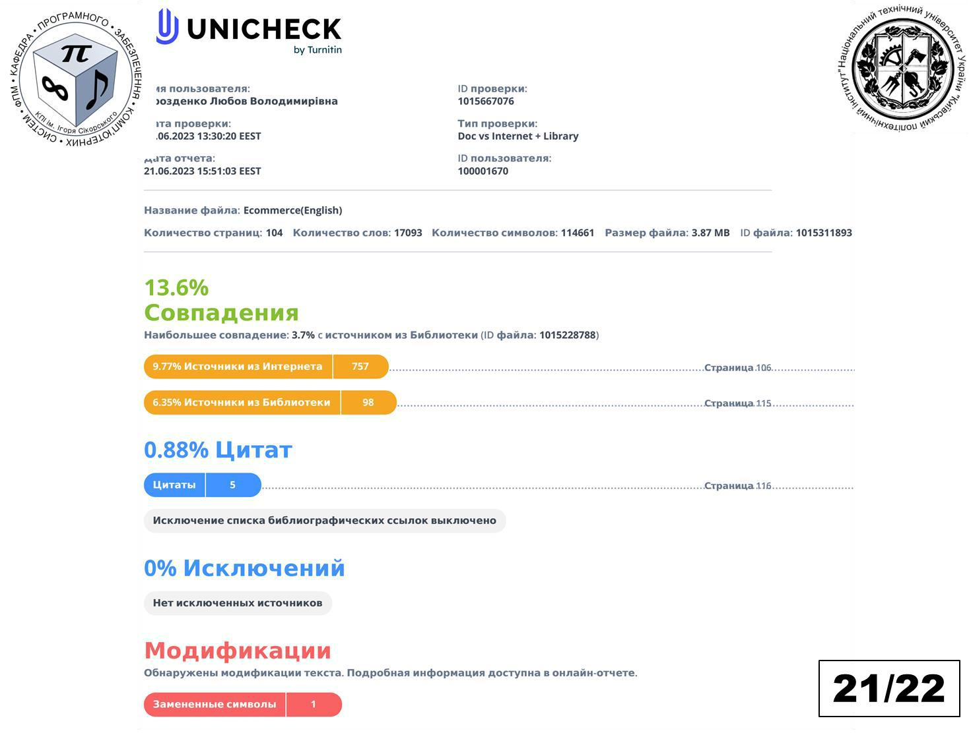

91



92

**Appendix 4**

**Program listing**

93

Base file (base.py)

import os



from decouple import config



BASE_DIR = os.path.dirname(os.path.dirname( os.path.dirname(os.path.abspath(__file__))))



SECRET_KEY = config('SECRET_KEY')



INSTALLED_APPS = [



'django.contrib.admin',



'django.contrib.auth',



'django.contrib.contenttypes',



'django.contrib.sessions',



'django.contrib.messages',



'django.contrib.staticfiles',



'core.apps.CoreConfig',



'django.contrib.sites',



'allauth',



'allauth.account',



'allauth.socialaccount',



'crispy_forms',



'django_countries',



]



MIDDLEWARE = [



'django.middleware.security.SecurityMiddleware',



'django.contrib.sessions.middleware.SessionMiddleware',



'django.middleware.common.CommonMiddleware',



'django.middleware.csrf.CsrfViewMiddleware',



'django.contrib.auth.middleware.AuthenticationMiddleware',



'django.contrib.messages.middleware.MessageMiddleware',



'django.middleware.clickjacking.XFrameOptionsMiddleware',



]



ROOT_URLCONF = 'djecommerce.urls'



TEMPLATES = [



{



'BACKEND': 'django.template.backends.django.DjangoTemplates',



'DIRS': [os.path.join(BASE_DIR, 'templates')],



'APP_DIRS': True,



94

'OPTIONS': {



'context_processors': [



'django.template.context_processors.debug', 'django.template.context_processors.request', 'django.contrib.auth.context_processors.auth', 'django.contrib.messages.context_processors.messages',



],



},



},



]



WSGI_APPLICATION = 'djecommerce.wsgi.application'



LANGUAGE_CODE = 'en-us'



USE_I18N = True



USE_L10N = True



USE_TZ = True



# Static files (CSS, JavaScript, Images)



STATIC_URL = '/static/'



MEDIA_URL = '/media/'



STATICFILES_DIRS = [os.path.join(BASE_DIR, 'static_in_env')]



STATIC_ROOT = os.path.join(BASE_DIR, 'static_root')



MEDIA_ROOT = os.path.join(BASE_DIR, 'media_root')



# Auth



AUTHENTICATION_BACKENDS = (



'django.contrib.auth.backends.ModelBackend',



'allauth.account.auth_backends.AuthenticationBackend'



)



SITE_ID = 1



LOGIN_REDIRECT_URL = '/'



# CRISPY FORMS



CRISPY_TEMPLATE_PACK = 'bootstrap4'



DEFAULT_AUTO_FIELD = 'django.db.models.BigAutoField'



# react



95

Manage file (manage.py)

import os



import sys



if __name__ == '__main__':



os.environ.setdefault('DJANGO_SETTINGS_MODULE',



'djecommerce.settings.development')



try:



from django.core.management import execute_from_command_line except ImportError as exc:



raise ImportError(



"Couldn't import Django"



) from exc



execute_from_command_line(sys.argv)



URL file (urls.py)

from django.urls import path



from django.views.generic import TemplateView from .views import (



ItemDetailView,



CheckoutView,



HomeView,



OrderSummaryView,



add_to_cart,



remove_from_cart,



remove_single_item_from_cart,



PaymentView,



AddCouponView,



RequestRefundView,



SearchView



)



app_name = 'core'



urlpatterns = [



path('', HomeView.as_view(), name='home'),



path('category/<str:category>/', HomeView.as_view(), name='category-filter'),



path('checkout/', CheckoutView.as_view(), name='checkout'), path('order-summary/', OrderSummaryView.as_view(), name='order-



summary'),



path('product/<slug>/', ItemDetailView.as_view(), name='product'),



96

path('add-to-cart/<slug>/', add_to_cart, name='add-to-cart'), path('add-coupon/', AddCouponView.as_view(), name='add-coupon'), path('remove-from-cart/<slug>/', remove_from_cart, name='remove-from-



cart'),



path('remove-item-from-cart/<slug>/', remove_single_item_from_cart, name='remove-single-item-from-cart'),



path('payment/<payment_option>/', PaymentView.as_view(), name='payment'),



path('request-refund/', RequestRefundView.as_view(), name='request-refund'),



path('search/', SearchView.as_view(), name='search'),



97

**Faculty of Applied Mathematics**

**Department of Computer Systems Software**

"APPROVED"

Department Head

________ Yevgeniya SULEMA

"___" ____________ 2023

**WEB APPLICATION FOR ELECTRONIC COMMERCE**

**PLATFORM**

**Testing program and methodology**

DP.045440-04-51

| "AGREED" |  |  |
| --- | --- | --- |
| Supervisor: |  |  |
| __________ Dmytro NOVAK |  |  |
| Normative control: |  |  |
| __________ Mykola ONAI | Performer: |  |
|  |  |
|  | __________ Mohamed Islam KHELILI |  |

2023

**CONTENT**

1. Object of tests ………………………………………………………..……... 3
2. Purpose of testing ……………………………………………………..……. 3
3. Methods of testing ………………………………………………………..… 3
4. Measures and procedure of testing ……………...………………………….. 4

2

**1. OBJECT OF TESTS**

The web resource of the Center for Electronic Education, which is a website created on the Microsoft .Net platform using Python and Django framework.

**2. PURPOSE OF TESTING**

During the testing process, the following should be checked:

1. functional effectiveness of the web application components;
2. seamless integration and interaction with the product database;
3. compatibility of data exchange formats and protocols within the e-commerce ecosystem;
4. adequate data security levels to protect sensitive user and transaction information;
5. usability and user-friendliness of the web application;
6. Compliance of the web application design with the specifications outlined in the technical requirements.

**3. METHODS OF TESTING**

Testing is performed using a combination of White Box and Black Box testing methodologies. Both the source code and the operational aspects of the software product are evaluated for their adherence to functional requirements. The testing procedure encompasses "system testing" levels.

The following methods are employed:

1. functional testing, specifically at the Critical Path Testing level (baseline testing);
2. performance testing of the software, including Stability testing and Load testing;
3. user Interface (UI) testing.

3

**4. MEASURES AND PROCEDURE OF TESTING**

Testing is conducted using testing tools such as Jest and Cypress.

The functionality of the web application is assessed through:

1. dynamic manual testing - by entering limit and unacceptable values in editable fields;
2. dynamic manual testing for compliance with functional requirements;
3. static code analysis;
4. cross-browser compatibility testing;
5. stress testing for maximum load conditions;
6. resilience testing under varying conditions;
7. usability testing;
8. user Interface testing.

4

**Faculty of Applied Mathematics**

**Department of Computer Systems Software**

"APPROVED"

Department Head

__________ Yevgeniya SULEMA

"___" ____________ 2023

**WEB APPLICATION FOR ELECTRONIC COMMERCE PLATFORM**

**User manual**

DP.045440-05-34

| "AGREED" |  |  |
| --- | --- | --- |
| Supervisor: |  |  |
| __________ Dmytro NOVAK |  |  |
| Normative control: |  |  |
| __________ Mykola ONAI | Performer: |  |
|  |  |
|  | __________ Mohamed Islam KHELILI |  |

2023

**CONTENT**

1. Description of the web application for electronic commerce …………… 3
2. Description of the content of static web pages …………...…….……….. 4
3. User authorization procedure ……………………………………...….… 7

2

**1. Description of the web application for electronic commerce**

An electronic commerce platform is a website or online system that helps businesses sell things on the internet. It's like a virtual store where people can buy and sell products without needing to be physically present.

The main job of an e-commerce platform is to make online shopping easy and safe. It has different features to support buying and selling:

* Product catalog: It's like an online store where businesses can display their products with descriptions, pictures, and prices. This helps customers see what's available and choose what they want to buy.
* Shopping cart: When customers find something they want, they can add it to their "shopping cart" or "basket." It's a virtual place where they can keep track of all the things they want to buy.
* Secure payment: To pay for their purchases, customers can use secure payment options like credit cards or digital wallets. The platform makes sure that their payment information is kept safe.
* Order management: The platform helps businesses manage the orders they receive. It keeps track of what needs to be shipped, what has been shipped, and it can send notifications to customers about their order status.
* Personalized recommendations: Some e-commerce platforms suggest products to customers based on what they've bought before or what they've looked at. This helps customers find things they might like and encourages them to buy more.
* Analytics and reports: The platform can provide businesses with information about how well their sales are doing. It can show data like how many people visit the site, how many people buy things, and other important numbers.

3

In summary, an electronic commerce platform is a website or online system that makes it easy and safe for businesses to sell things online. It helps businesses show their products, lets customers buy them securely, and provides tools to manage orders and track sales.

**2. Description of the content of static web pages**

Page "Home page" / "Home page" (Fig. 1) contains basic information about the e-commerce platform, The homepage is the first page visitors see when they access the e-commerce website. It usually provides an overview of the business, featuring branding elements such as the company logo, tagline, and a brief introduction. The homepage may also highlight featured products, current promotions, and provide navigation options to other sections of the website.

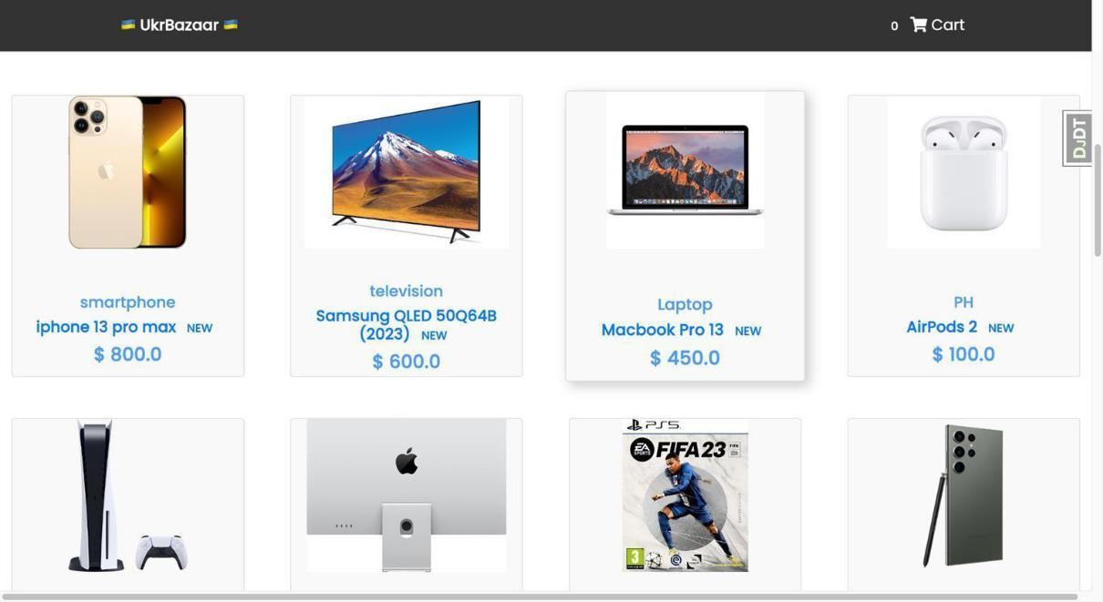

Fig. 1. "Homepage" page

Product Page: (Fig. 2). Product pages provide detailed information about specific products or services offered by the e-commerce platform. Each product page typically includes product images, descriptions, specifications, pricing, and

4

any available options or variations. These pages aim to showcase the product's features and benefits, helping customers make informed purchasing decisions.

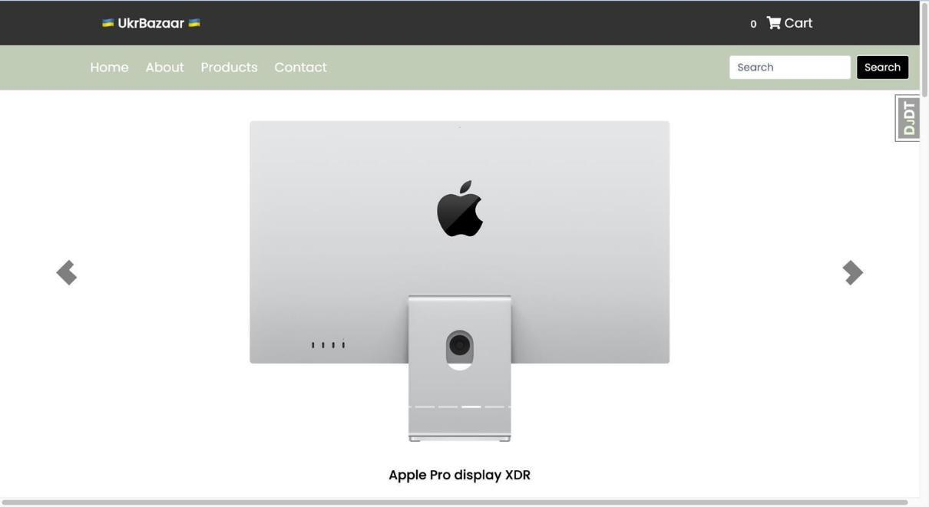

Fig. 2. "Product" page

Cart shipping (Fig. 3) is the process of delivering the items in your shopping cart to your specified address. After reviewing your cart and providing the shipping details, you can choose a shipping method and pay for it. Once the products are shipped, you can track the package until it arrives at your doorstep. It ensures that your purchased items reach you safely and conveniently.

The checkout form is where customers fill in their own information to complete their purchase. It usually includes fields for the customer's name, email address, shipping address, and payment details. By providing these details accurately, customers ensure that their order is processed correctly and that the products are delivered to the right place. The checkout form is a vital step in the buying process, allowing customers to finalize their purchase and receive their desired items

5

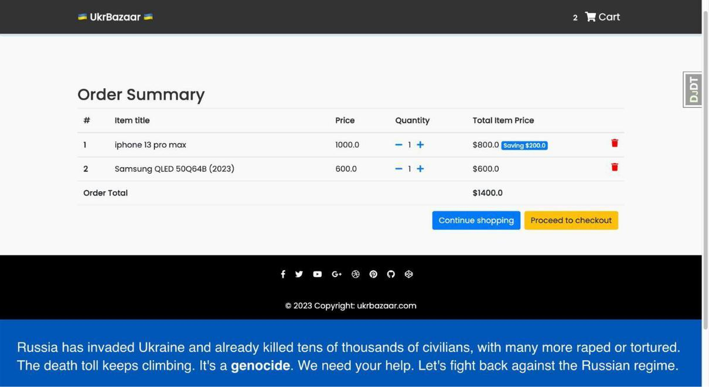

Fig. 3. "Card shipping" page

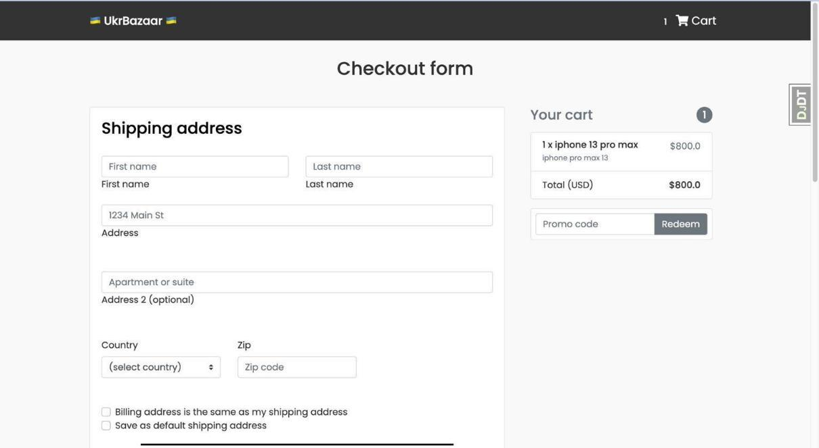

Fig. 4. "Checkout form" page

The payment page (Fig 4) is where users select their preferred payment method and enter their card information to complete the transaction. It typically presents options like credit card, debit card, or online payment platforms. Users choose their method and provide their card number, expiration date, and security code.

6

This step ensures secure payment processing, allowing users to finalize their purchase and complete the transaction with their chosen payment method.



Fig. 4. "Payment" page

**3. User authorization procedure**

The user authorization procedure is the process by which users gain access to a system or platform with specific permissions and privileges. Here is a description of the typical steps involved in a user authorization procedure:

* Browse: Users can visit the website and freely browse the product catalog.
* Select Products: Users can choose the products they want by adding them to their cart.
* View Cart: Users can view the contents of their cart, including the selected products and their quantities.
* Proceed to Checkout: When ready to make a purchase, users can proceed to the checkout process.

7

* Provide Contact Information: Users may need to provide their contact information, such as their name, email address, and shipping address, during the checkout process.
* Select Payment Method: Users can choose their preferred payment method, such as credit card or online payment platforms.
* Complete Purchase: Users confirm their order and proceed to complete the purchase using the selected payment method.

8